MAIN INSTRUMENT

Commodity Flow Survey Respondent Login/Welcome Screen

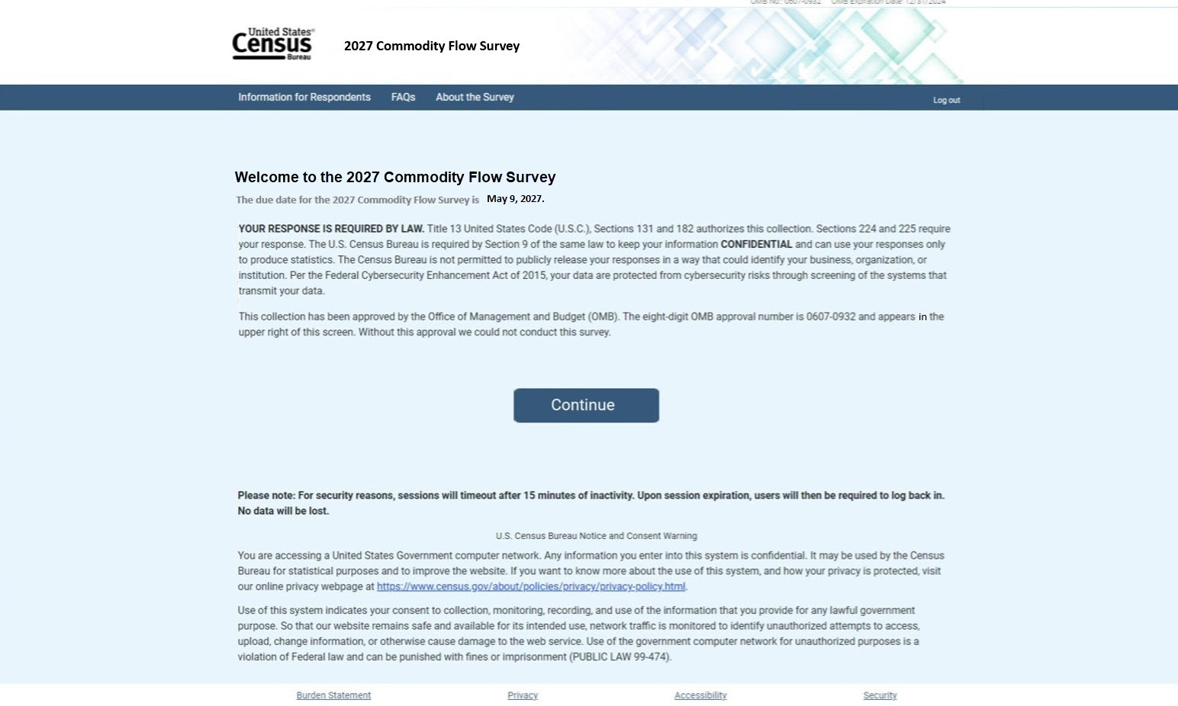

Burden Statement

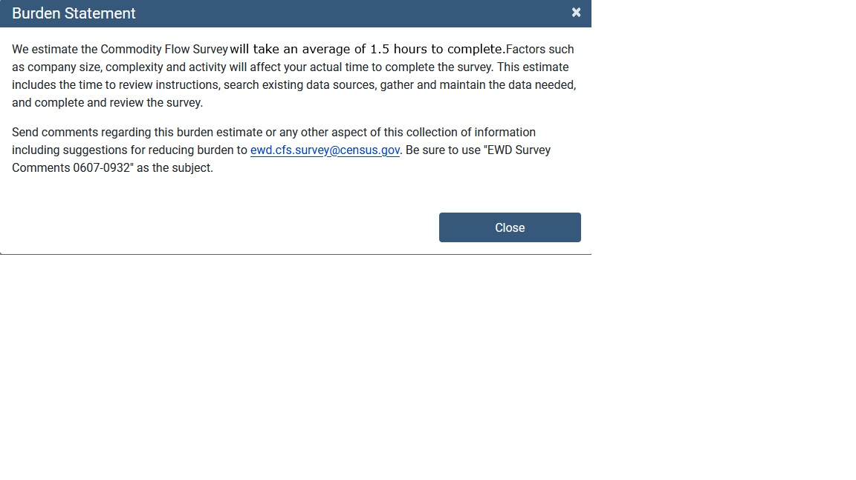

If Individual Location Reporter – Main Menu
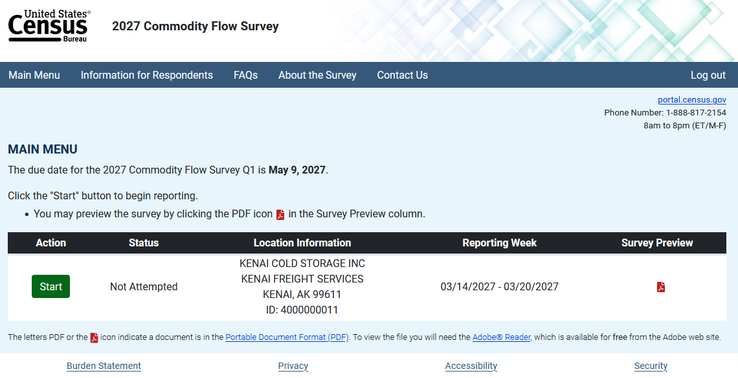

Is Company a Consolidated Reporter – Reporting Method Option

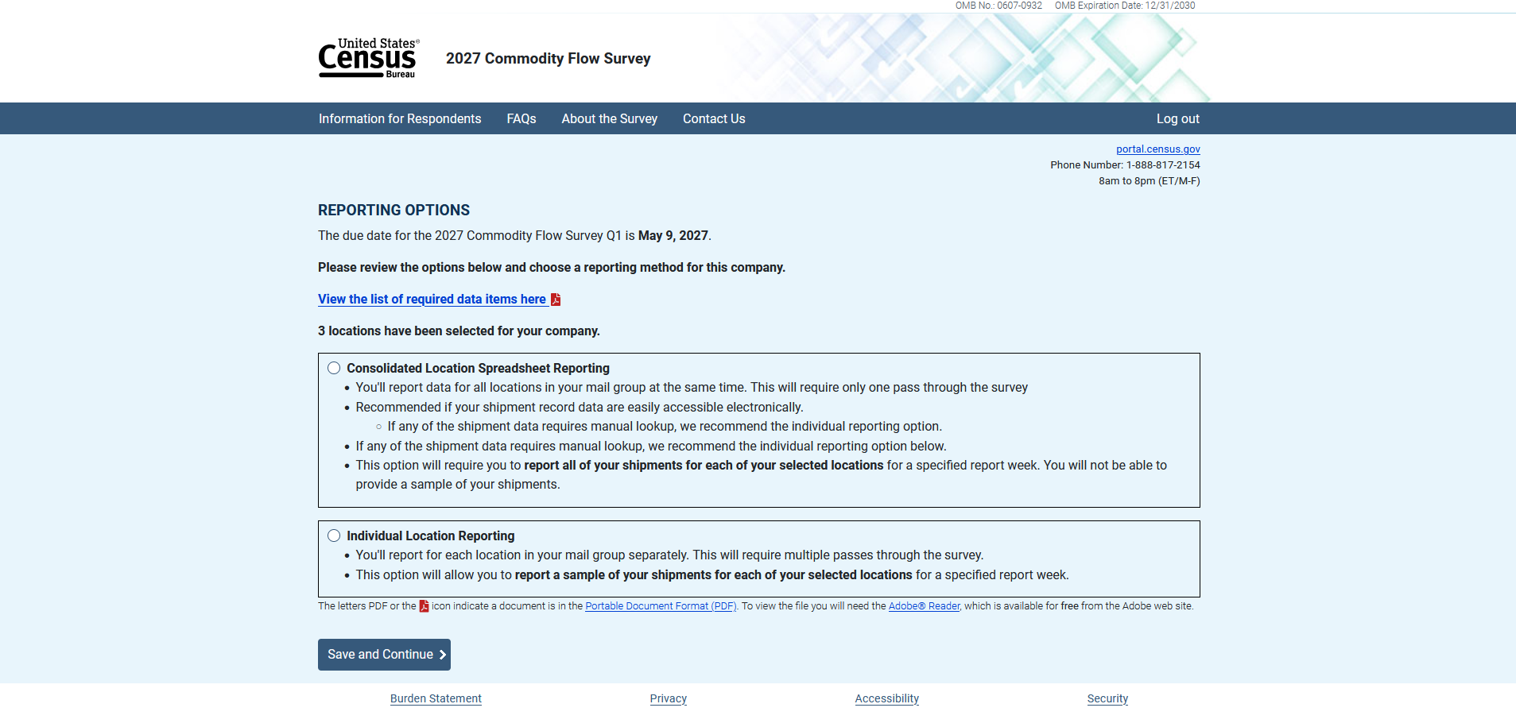

Company Consolidated Spreadsheet Reporter Option – Main Menu
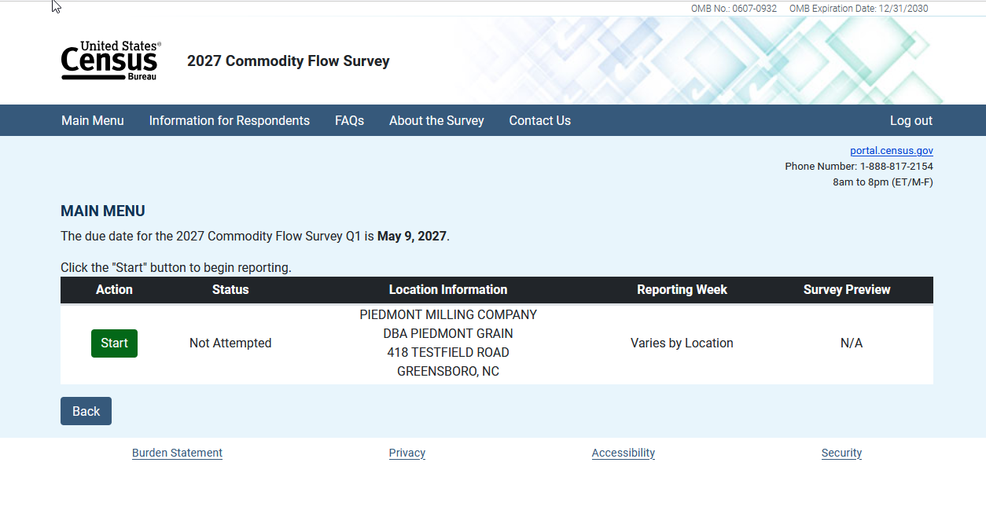

Company Reporting Individual Locations Option – Main Menu
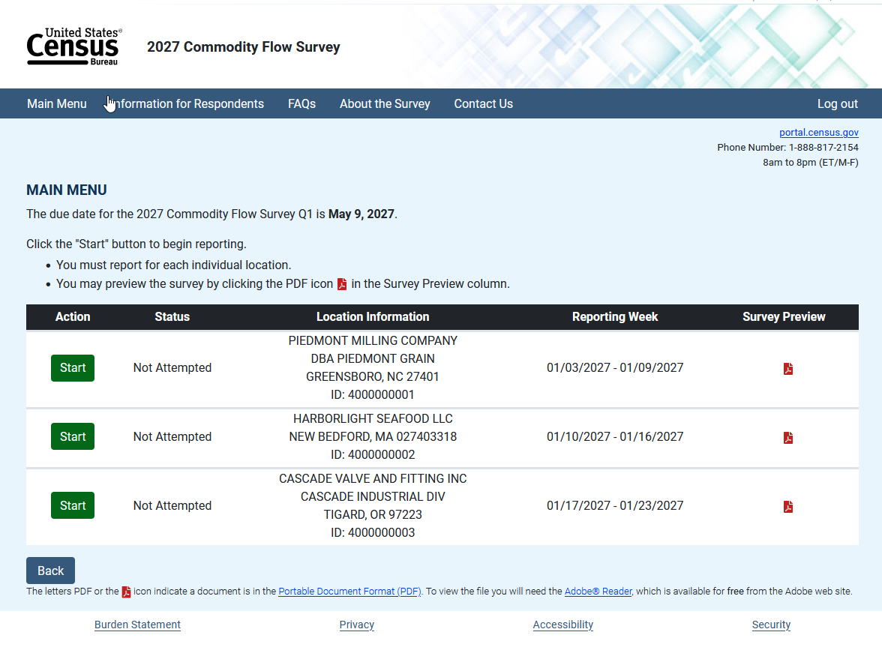
Item A1 – Company Information – All reporters

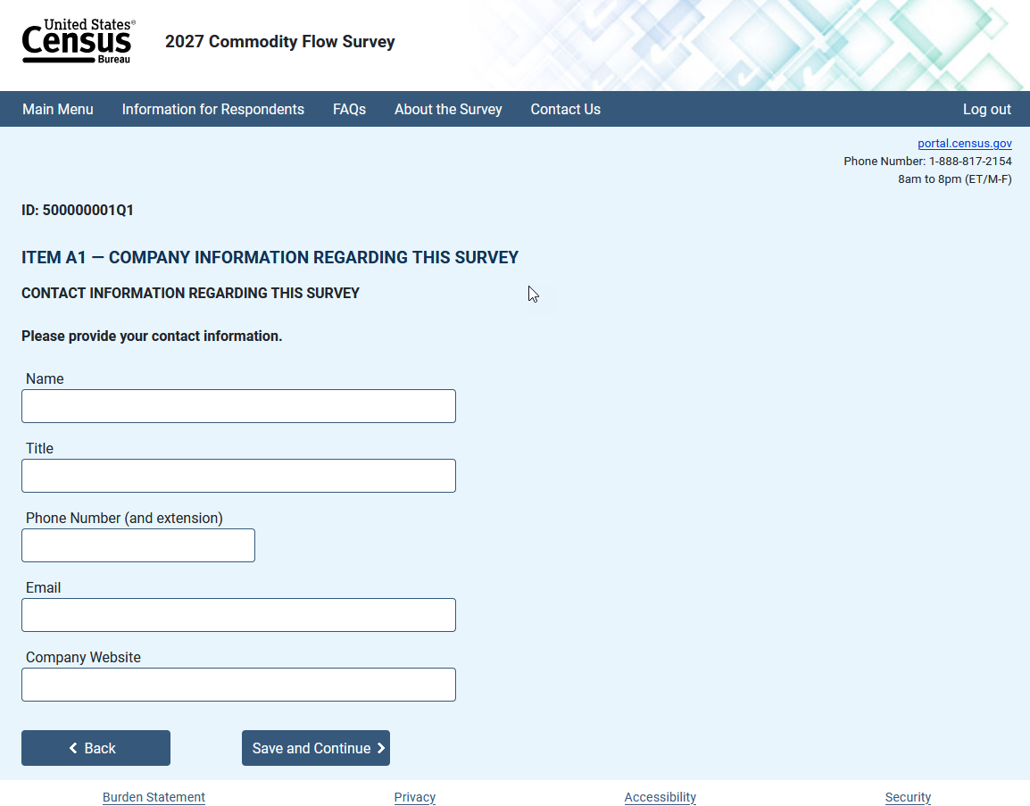

Item A2 – Company Name and Mailing Address

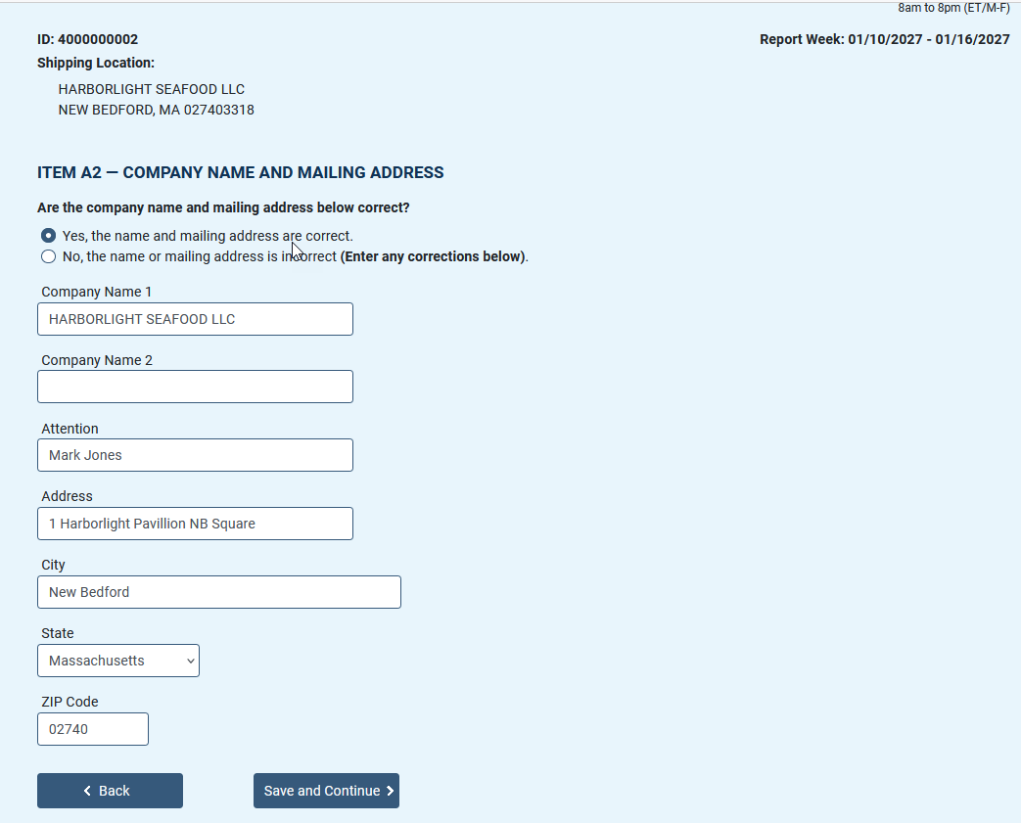

Item A3 – Shipping Location Information

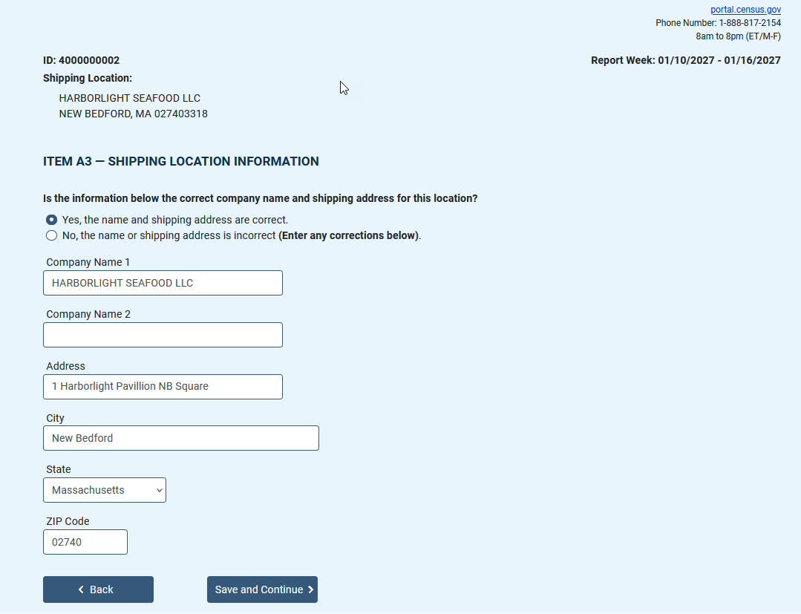

Item C – Operating Status

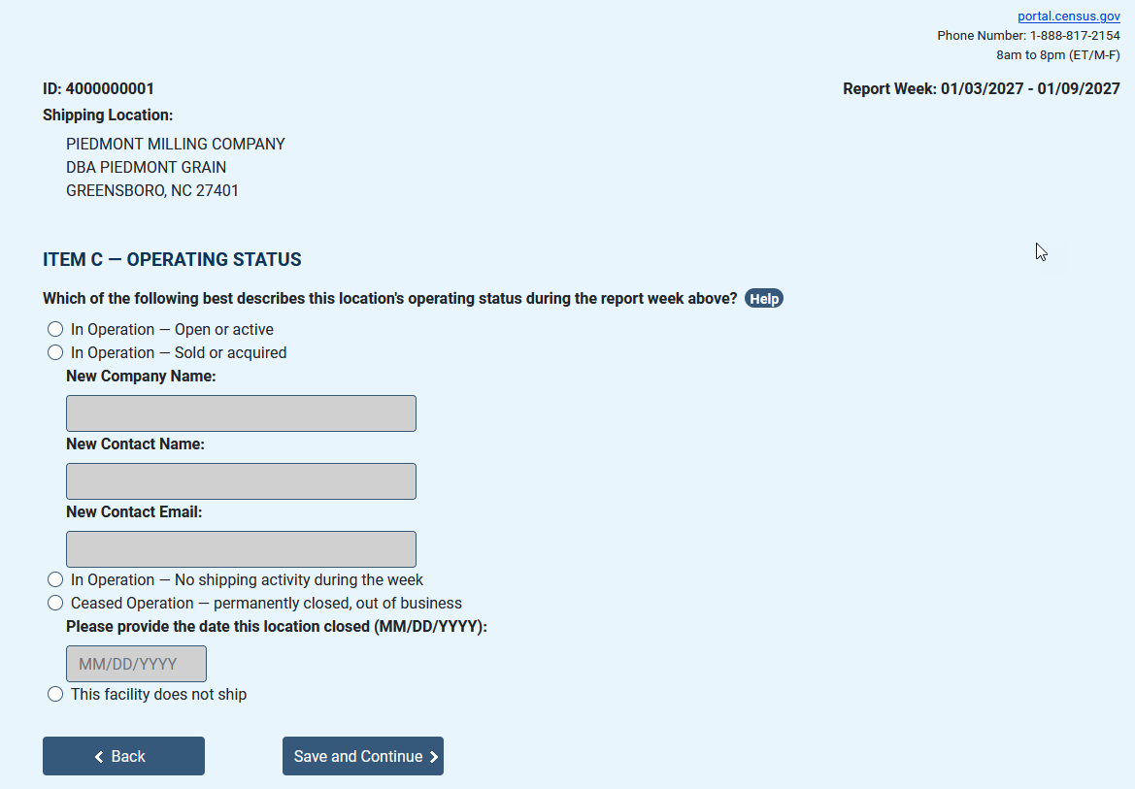

Shipping Location

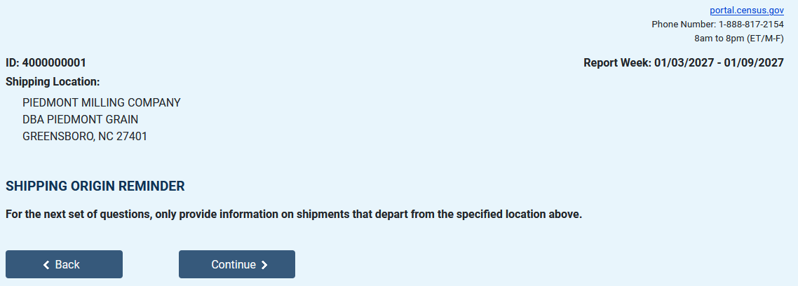

Item D2 – Total Number and Value of Outbound Shipments

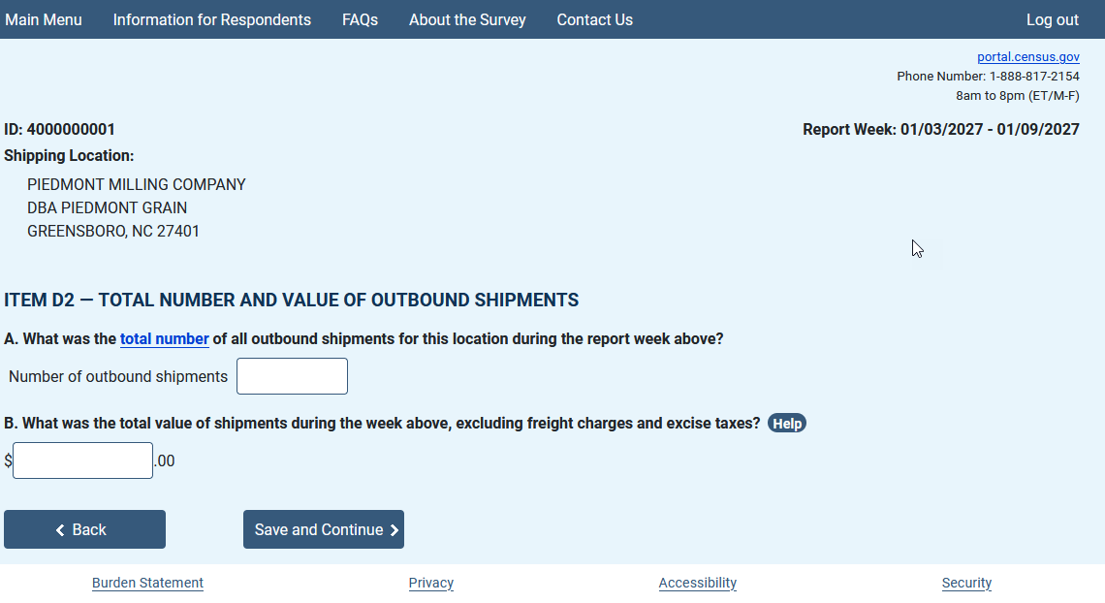

Item F1 – Shipment Reporting Options

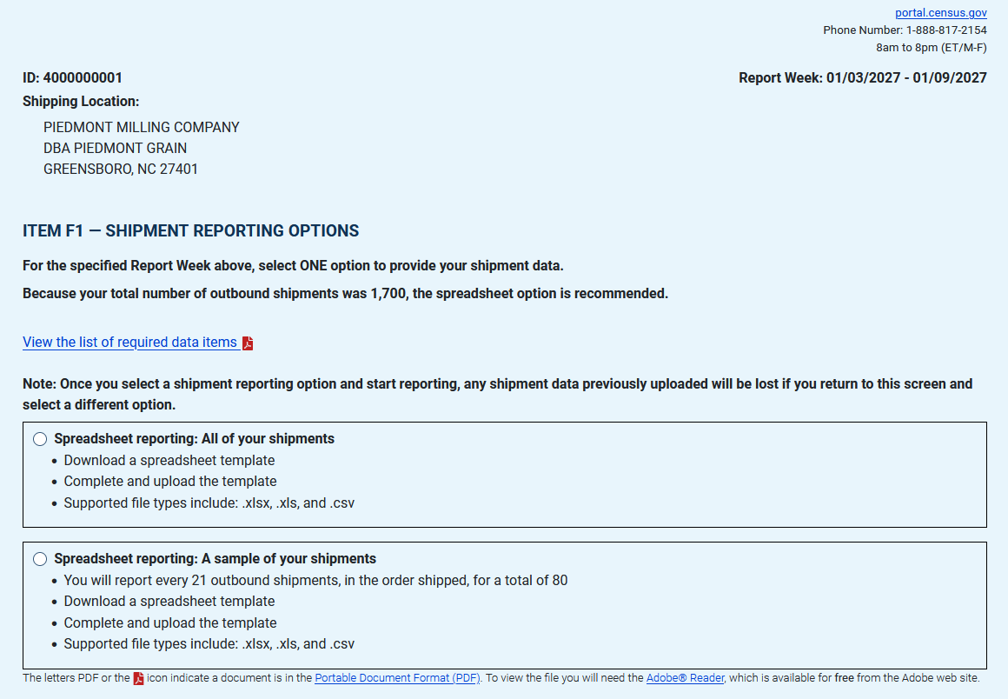

Consolidated and/or Individual Location Spreadsheet Reporting only - Upload Your Shipments

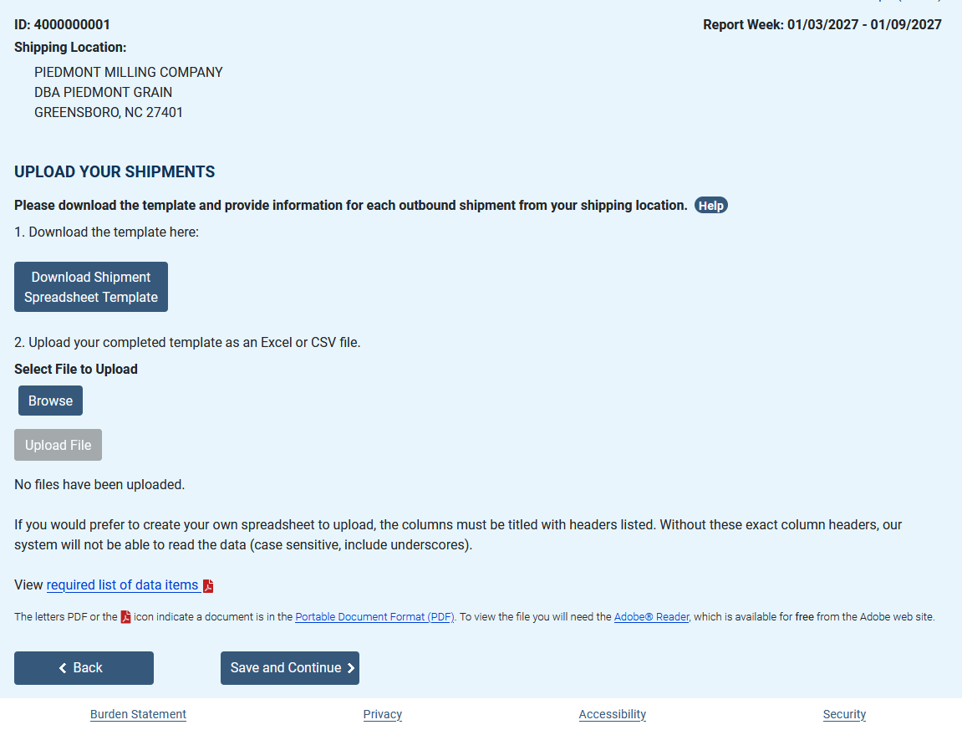

Individual Location Reporting Item F – Shipment Characteristics Summary

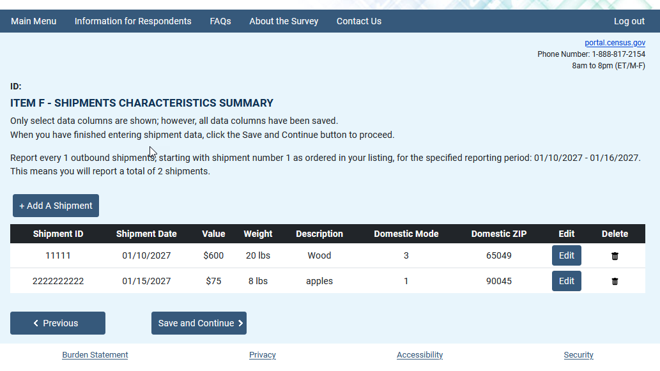

Individual Location Reporting – Item F3 – Shipment Characteristics (displays on the dashboard, previous screen, with each additional shipment)

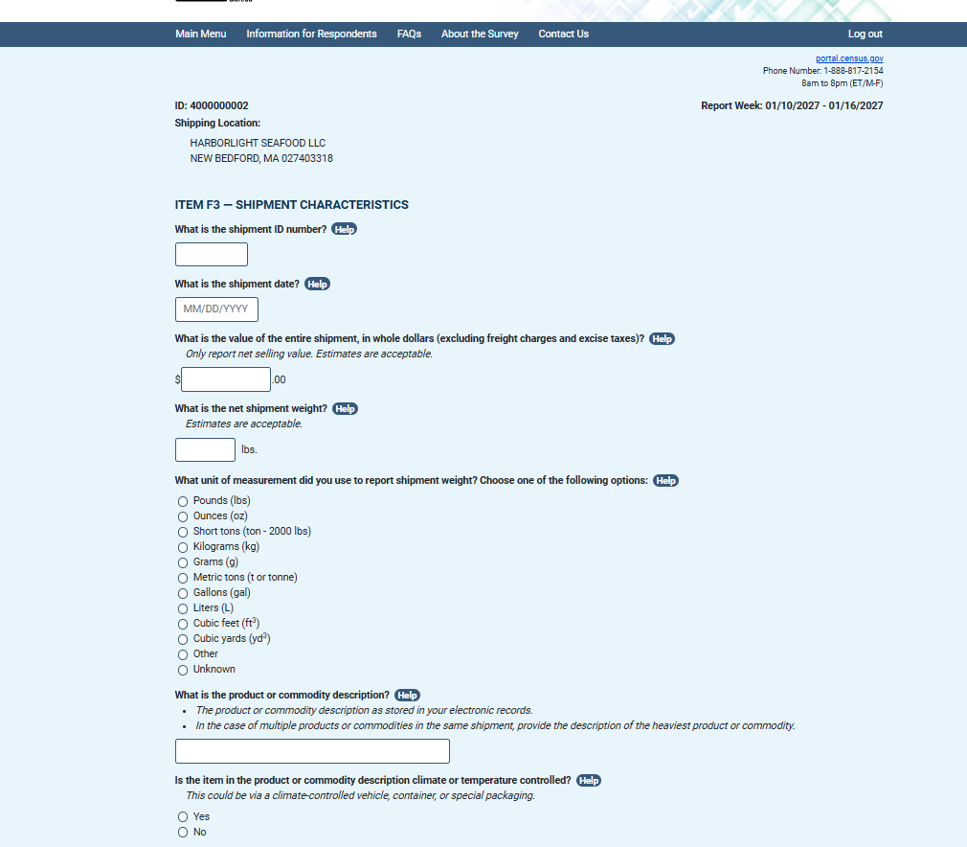

Individual Location Reporting – Item F3 (Continued) – Shipment Characteristics (displays on the dashboard, previous screen, with each additional shipment)

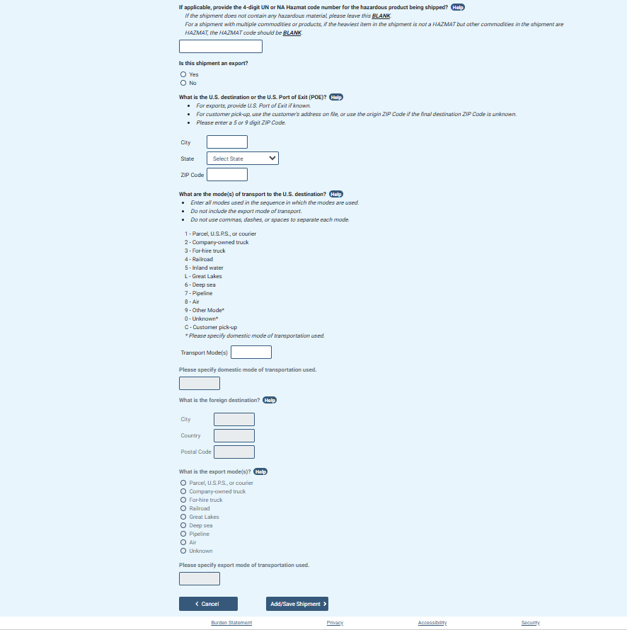

Item H – 2026 Total Annual Value of Shipments

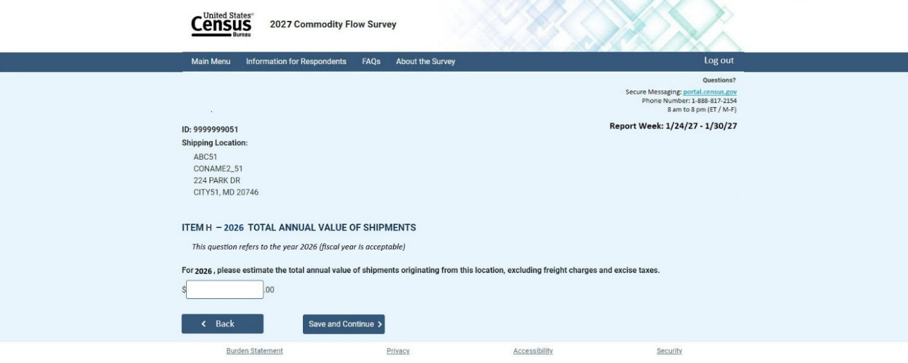

Item I – Time to Complete Survey

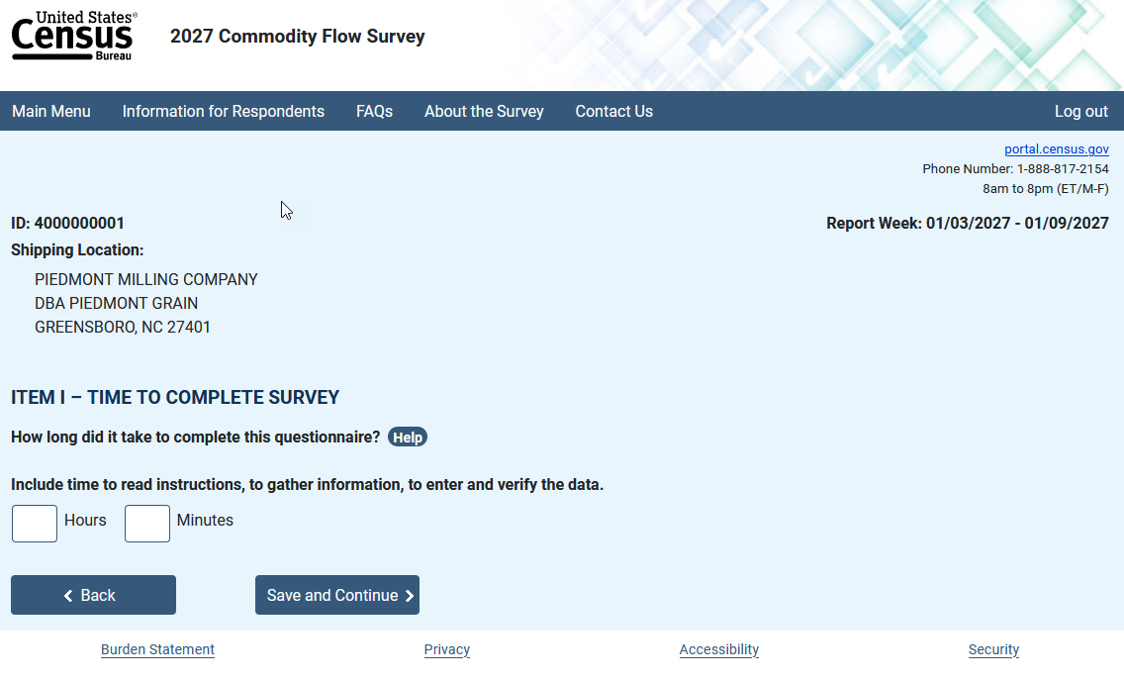

Item J – Remarks

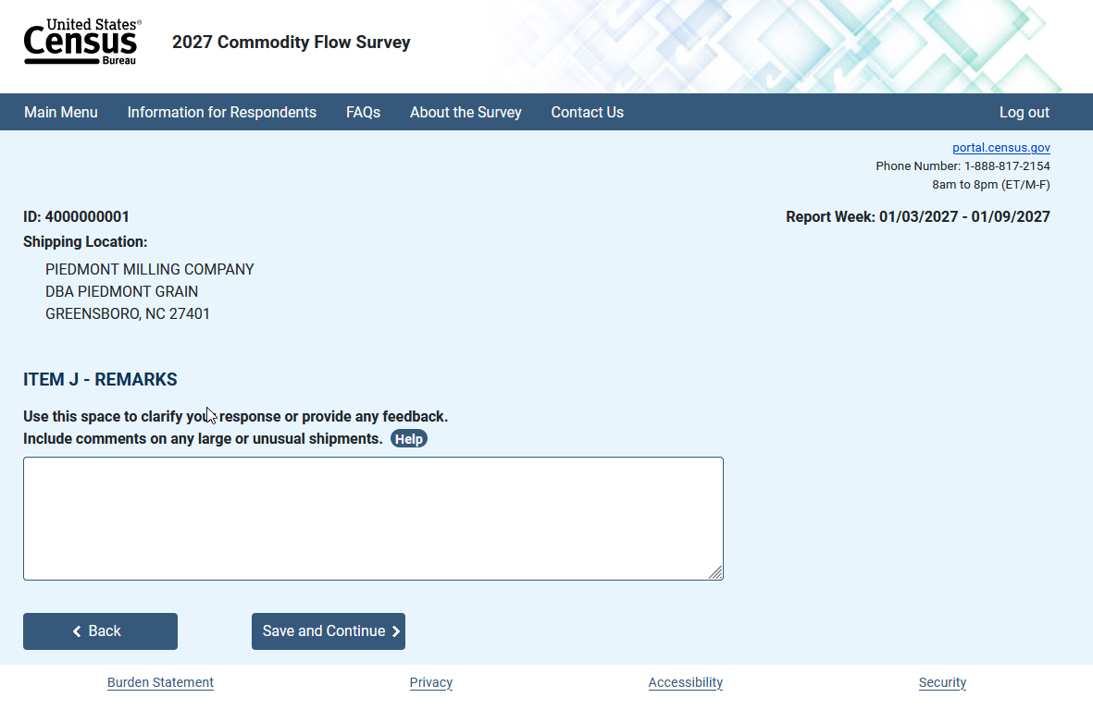

Review Your Responses

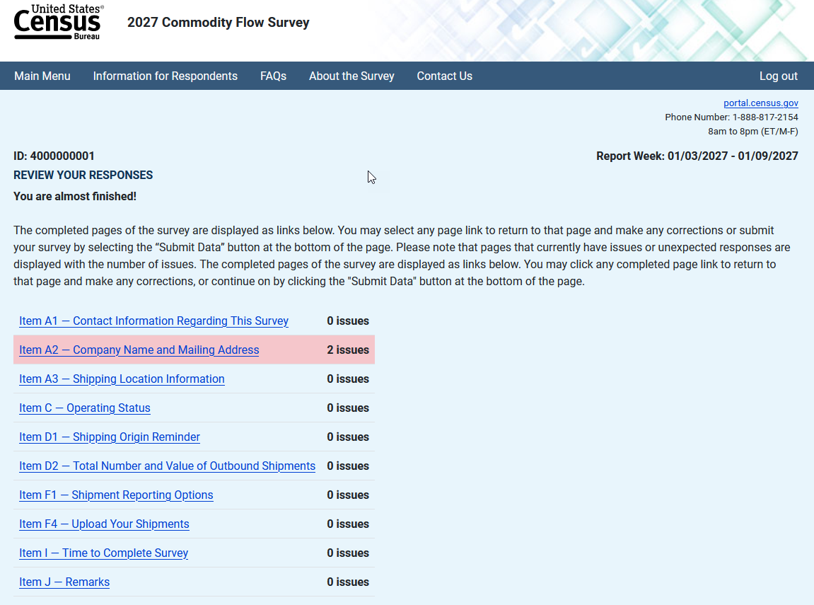

Submission Confirmation

