Database Example
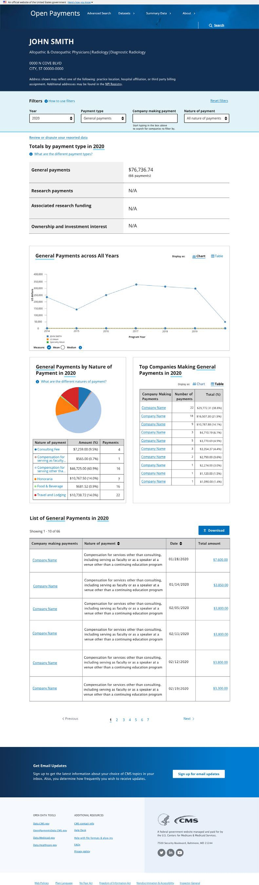

Provider Fact Sheet
