CMS Applicant Information Collection Form

PRA Disclosure Statement
According to the Paperwork Reduction Act of 1995, no persons are required to respond to a collection of information unless it displays a valid OMB control number. The valid OMB control number for this information collection is 0938-1185 (Expires 03/31/2026). The time required to complete this information collection is estimated to average two minutes per response, including the time to review instructions, search existing data resources, gather the data needed, and complete and review the information collection. This is voluntary information collection to help CMS capture recruitment event data, career interest and contact information from people individuals interested in CMS careers at events, webinars, or through other digital channels. The information is associated with the System of Record of Notice (SORN) OPM GOVT-5. The name of the system is Recruiting, Examining and Placement Records. If you have comments concerning the accuracy of the time estimate(s) or suggestions for improving this form, please write to: CMS, 7500 Security Boulevard, Attn: PRA Reports Clearance Officer, Mail Stop C4-26-05, Baltimore, Maryland 21244-1850. ****CMS Disclosure**** Please do not send applications, claims, payments, medical records or any documents containing sensitive information to the PRA Reports Clearance Office. Please note that any correspondence not pertaining to the information collection burden approved under the associated OMB control number listed on this form will not be reviewed, forwarded, or retained. If you have questions or concerns regarding where to submit your documents, please contact CMSRecruitment@cms.hhs.gov.

Thank you for your interest in exploring new career opportunities with CMS. Please complete the candidate questionnaire to be notified about future career opportunities, events, and webinars at CMS.

Thank you,

CMS Recruitment Team

Required: First Name
Required: Last Name
Required: Email Address
Required: Phone Number
Required: Are you a US Citizen?
- Yes / No
Type of Position Seeking
- Student / Entry / Mid-Career / Senior Executive
Career Field of Interest
- Accounting / Actuary / Auditing / Information Technology / Cyber Security / Nursing / Physician / Data Science / Human Resources / Health Policy / Legal / Contracting / Finance & Budget / Statistician / Pharmacist/ Economist / Occupational Health / Public Affairs & Communications / Web Design / Product Development / Clinical Laboratory Science / Management & Program Analysis / Equal Opportunity / Social Science Research / Emergency Management / Security Administration
Degree Level (pursuing or highest level achieved)
- High School / Associate’s Degree / Bachelor’s Degree / Master’s Degree / PhD / JD / MD
University
- This will include 1762 U.S. accredited colleges and universities. Due to space saving did not include in this document. Full list can be found here: https://www.4icu.org/us/a-z/
Major (can select multiple)
- This will include over 200 majors. For space saving, included full list below.

Graduation Month
- January / February / March / April / May / June / July / August / September / October/ November/ December
Graduation Year
- 1970 - 2023
Overall GPA
- 2.0 - 4.00
Additional Degree
- Yes / No
Additional Degree Level
- Associate’s Degree / Bachelor’s Degree / Master’s Degree / PhD / JD / MD
Additional University
- This will include 1762 U.S. accredited colleges and universities. Due to space saving did not include in this document. Full list can be found here: https://www.4icu.org/us/a-z/
Additional Major
- This will include over 200 majors. For space saving, included full list below.
Additional Graduation Month
- January / February / March / April / May / June / July / August / September / October/ November/ December
Additional Graduation Year
1970 - 2023
Additional Overall GPA
- 2.00 – 4.0
Required: Location Preference
- List all U.S. States
Are you a current Federal Employee?
- Yes / No
What is your current grade level (Equivalent in GS)?
- GS-1 – GS-15, SES Level I – V
Are you or have you ever served in the Armed Forces?
- Yes / No
Separation Date (or anticipated separation date) – Month
- January / February / March / April / May / June / July / August / September / October/ November/ December
Separation Date (or anticipated separation date) – Year
- 1970 - 2023
Do you have a documented disability rating of at least 30%?
- Yes / No
Are you schedule A eligible? (This excepted authority is used to appoint persons with severe physical disabilities, psychiatric disabilities, and intellectual disabilities. To be eligible for a Schedule A appointment, applicants must provide proof of disability and job readiness certification from a licensed medical professional, a licensed vocational rehabilitation specialist, or federal or state agency that issues or provides disability benefits.)
Yes / No
Licenses/Certifications
- Open text box
Are you a veteran?
Yes
No
Undisclosed

Gender: Are you: (Mark all that apply)

Female
Male
Transgender, non-binary, or another gender

Required: CMS Privacy Policy

PRIVACY ACT STATEMENT -
1. AUTHORITY: Title 5 of the United States Code sections 1104, 1302, 3301, 3304, 3320, 3361, 3393, and 3394 provide The U.S. Office of Personnel Management and other Federal agencies the authority to rate applicants for Federal jobs.
2. PURPOSE: We need the information requested in this form to complete the registration process and provide you with information regarding upcoming career opportunities, events, or webinars at CMS.
3. ROUTINE USES: The CMS Recruitment Team is not accepting applications or qualifying applicants through this candidate questionnaire. Interested applicants must apply through USAJOBS and should follow the instructions as provided in the vacancy announcement under the “How To Apply” section.
4. DISCLOSURE: Providing this information is voluntary, however failure to furnish the requested information may limit communications about career opportunities, events, and webinars.

I agree to the CMS Privacy Policy.

Submit

Example: NAVAIR Information Collection Form

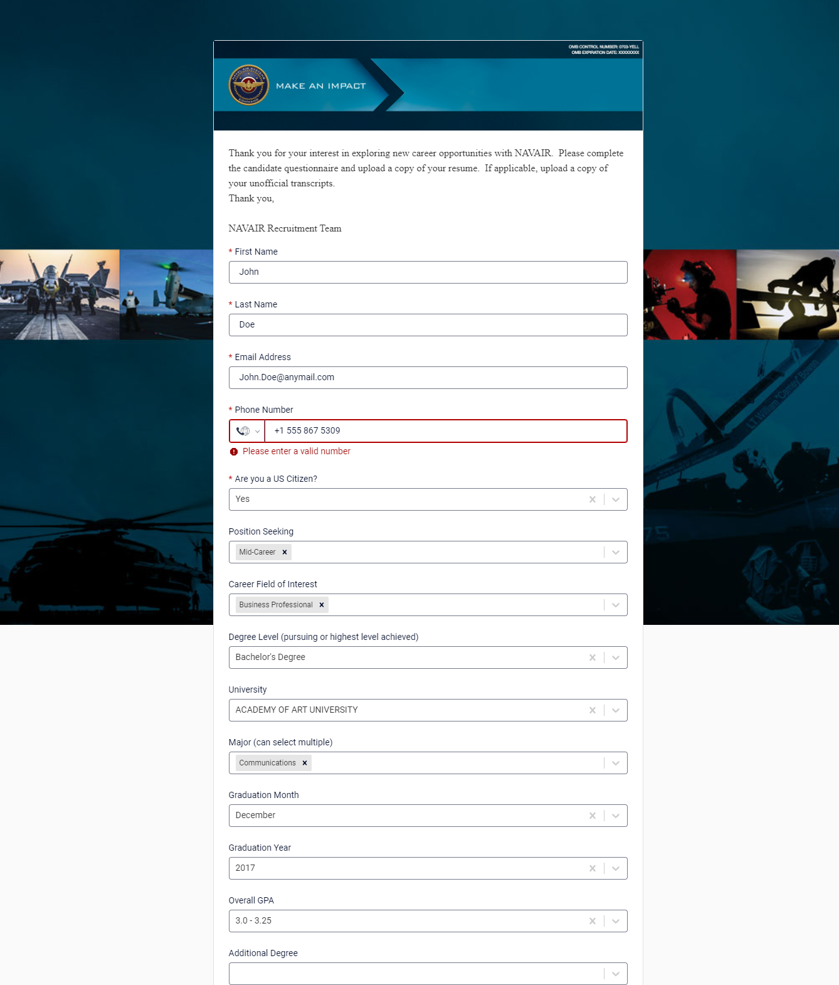

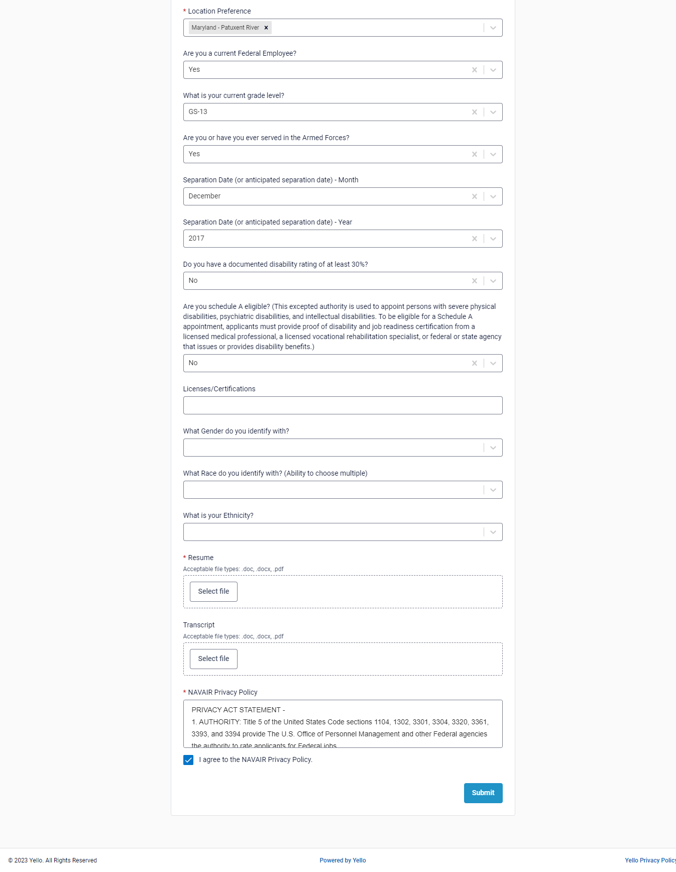

List of Majors:

Agriculture, Outdoor, and Construction

Aeronautics
Agricultural Business & Technology
Agriculture
Agricultural Economics
Agricultural Operations
Animal Sciences
Construction Engineering Technology
Construction Management
Fish and Wildlands Science and Management
Food Science

Art

Animation
Art
Art History
Cinematography
Dance
Digital Arts
Drama
Fashion Design
Film
Game Design
Graphic Design
Industrial Design
Illustration
Interior Design
Multimedia
Music
Music Management
Music Performance
Photography
Studio Art
Visual and Performing Arts
Visual Design

Business

Accounting
Actuarial Science
Advertising
Business
Business Administration
Business, Management, and Related Support Services
Econometrics
Economics
Entrepreneurship
Fashion Merchandising
Finance
Human Resources Management
International Business
Insurance
Management
Management Information Systems
Management Science
Managerial Economics
Marketing
Operations Management
Organizational Behavior
Real Estate
Sales
Supply Chain Management

Education

Early Childhood Education
Education
Education (Other)
Elementary Education
Health and Physical Education
Language Arts Teacher Education
Mathematics Teacher Education
Middle School Education
Music Teacher Education
Physical Education Teaching and Coaching
Secondary Education
Special Education
Teacher Education

Health

Athletic Training
Audiology
Clinical Laboratory Science
Cognitive Science
Communication Sciences
Community Health
Community Health Services
Dental Hygiene
Health and Wellness
Health Care Administration
Health Information
Health/Medical Preparatory Programs
Health Professions and Related Clinical Sciences
Health Services
Hospital and Health Care Facilities Administration
Medical Radiologic Technology
Nursing
Nursing Research
Nursing Science
Nutrition
Nutrition Sciences
Public Health
Public Health Education
Radiologic Technology
Respiratory Care Therapy
Speech-Language Pathology

Humanities

Applied Communication
Biblical Studies
Communication
Communication and Media Studies
Creative Writing
Digital Communication and Multimedia
English
Foreign Languages and Literature
French Language and Literature
Gender Studies
General Studies
General Studies and Humanities
History
Humanities
Journalism
Liberal Arts
Linguistics
Mass Communication
Organizational Communication
Parks, Recreation and Leisure Facilities Management
Parks, Recreation and Leisure Studies
Philosophy
Public Relations
Public Relations/Image Management
Radio and Television
Religious Studies
Rhetoric and Composition
Spanish Language and Literature
Speech and Rhetoric
Talmudic Studies
Theology

Law and Politics

Community Organization and Advocacy
Geography
International Relations
International Studies
Legal Assistant
Legal Studies
Political Science
Public Administration
Public Policy Analysis
Social Work
Sociology

Social Science

Anthropology
Behavioral Sciences
Child Development
Criminology
Experimental Psychology
Human Development and Family Studies
Psychology

STEM

Aerospace Engineering
Applied Mathematics
Architecture
Astrophysics
Biochemistry
Biological and Biomedical Sciences
Biological and Physical Sciences
Biology
Biomedical Engineering
Biomedical Sciences
Cellular and Molecular Biology
Chemical Engineering
Chemistry
Civil Engineering
Computer Engineering
Computer and Information Sciences
Computer Science
Computer Software Engineering
Computer Systems Networking
Conservation
Data Science
Earth Science
Electrical Engineering
Engineering
Environmental Science
Environmental Studies
Exercise Physiology
Informatics
Information Science
Information Systems Security
Information Technology (IT)
Kinesiology
Marine Biology
Mathematics
Mechanical Engineering
Microbiology
Neuroscience
Petroleum Engineering
Physics
Physiology, Pathology, and Related Sciences, Other
Statistics
Web Design
Zoology

Other

Apparel and Textiles
Corrections and Criminal Justice
Criminal Justice
Electromechanical Technology
Foods, Nutrition, and Wellness Studies
Forensic Science and Technology
Hospitality Administration
Hotel Management
Human Sciences (General)
Human Services
Law Enforcement Administration
Police Science
Sport and Fitness Administration

