Rural Health Transformation (RHT) Program:
A Guide to State Awardee Reporting

Table of Contents
I. Introduction 2
II. RHT Program Reporting Requirements 3
III. Reporting Cadence & Periods 3
IV. Annual, Quarterly, and Final Reports 3
Annual Reporting and Quarterly Reporting Elements 3
Final Report 4
V. Reporting Elements 5
VI. Completing Reports 5
VIII. MDCT RHTP Platform Overview & Guidance 6
Instructions 7
1. General Information 7
2. Initiatives 10
3. Initiative Attachments 18
4. State Policy Action Commitments 25
5. Obligated and Spent Funds Reporting 27
6. Sustainability & Highlights 29
7. Review & Submit 31
IX. Appendix 35
A. Annual and Quarterly Reporting Periods 35
B. Resources 36
C. State Progress Reporting Frequently Asked Questions (FAQs) 36
Reporting Submission Process 36
State Reporting Non-Compliance 38
D. Getting Started – Submitting the Initial Annual Report 39
Instructions 39
1. Initiative Forms 40
2. State Policy Action Commitments Form 45
3. Obligated and Spent Funds Reporting Tabs 48
4. Additional Information Form 48
5. Submitting Evidentiary Documentation 51
6. Submitting the Initial Annual Report 52
E. Table of Figures 54

Introduction
As partners in a Cooperative Agreement, we have a shared goal: the success of each State’s Rural Health Transformation (RHT) Program. States’ core responsibility is to comply with all Terms and Conditions in their Notice of Award (NoA). Here’s what that looks like in practice:
- Fulfilling Requirements: Submit all required reporting as detailed in the NoA.
Resources & Support
We are here to help States succeed! To ensure seamless, coordinated support, please copy both the State’s PO and GMS in all correspondence. Direct programmatic questions to the State’s PO, and financial or award administration questions to their GMS.
- Managing the Work Plan: Submit performance measures as agreed upon and submit subsequent revisions of the State’s work plan for CMS approval.
- Staying Connected: Collaborate with the State’s Project Officer (PO), and, as applicable, Grants Management Specialist (GMS) to discuss progress and seek support on reporting activities as needed. An active partnership is key to success!
- Subrecipient Oversight: Confirm that subrecipients, contractors, and partners are compliant with all administrative and policy requirements, including reporting. Note that the Terms and Conditions of the NoA flow down to subrecipients.
The primary goal of this guide is to equip States with the knowledge and tools needed to meet post-award reporting responsibilities efficiently and effectively. Timely and accurate reporting is the principal way we measure progress, promote accountability, and document the incredible work being done. The information States provide is critical for demonstrating the value of the RHT Program and informing programmatic funding decisions.
For additional supplemental information and reference materials, please refer to the Appendix section.
After reviewing this guide, States will be able to prepare the following progress reports that meet RHT Program requirements:
- Annual Reports
- Quarterly Reports
- Final Report

RHT Program Reporting Requirements
While this guide focuses on the successful preparation and submission of Annual and Quarterly Reports, as well as the Final Report, it is important to recognize that these reports are part of a broader landscape of post-award responsibilities. The full scope of federal reporting requirements, as detailed in the Notice of Funding Opportunity (NOFO), include:
- Non-Competing Continuation (NCC) Application
- Federal Financial Reports (FFR)
- Federal Funding Accountability and Transparency Act (FFATA) Reporting
- Work Plan Updates
- Progress Reports
- SAM.gov Records
- Payment Management System (PMS) Reports, and
- Audit Reporting
Please refer to the Program Terms and Conditions located within the State’s NoA, NOFO, and CMS website for additional information.

Reporting Cadence & Periods
State awardees are required to submit Annual and Quarterly Progress Reports along with a one-time Final Report. These reports must be submitted for all five budget periods (FY26-FY30). These reports are crucial for CMS to make funding decisions for subsequent budget periods.
While Budget Period 1 required only an Annual Report, quarterly reporting will commence in Budget Period 2 and continue alongside the annual reporting schedule throughout the Program’s period of performance. For a comprehensive table of reporting dates, refer to Appendix A.

Annual, Quarterly, and Final Reports
The following section details each of the progress reports required throughout the RHT Program.

Annual Reporting and Quarterly Reporting Elements
The Annual Report delivers a summary of programmatic progress over the reporting period. Specific components of the Annual Report will be scored and used to determine subsequent funding. The general reporting periods are as follows: December 29, 2025 - July 31, 2026, August 1, 2026 - July 3, 2027, August 1, 2027 - July 31, 2028, August 1, 2028-July 31, 2029, and August 1, 2029 - July 31, 2030.
The Quarterly Report encompasses programmatic progress achieved during the specified quarter. The information from these Quarterly Reports will be used to progressively build and update the Annual Report throughout each budget period. The general reporting periods are as follows: August 1- October 30, October 31- January 30, and January 31- April 30. Please refer to Appendix A for a comprehensive view of all reporting periods and deadlines.
Figure 1 below specifies each reporting element States are responsible for, detailing both annual and quarterly submission requirements:
Figure 1: Reporting Elements
Reporting Element | Annual | Quarterly
Initiative Progress Narrative | Required | Optional
Initiative Number of People Served | Required | Optional
Initiative Metrics | Required | Optional
Initiative Checkpoints | Required | Required
State Policy Action Commitments | Required | Required
Obligated and Spent Funds | Required | Required
Success Stories and Highlights | Required | Optional
Sustainability Planning | Required | Optional
Definition of Rural Area | Required only in Annual Report #1 | N/A

Final Report
At the conclusion of the five-year period of performance, States are required to submit a single Final Report capturing all cumulative activities. More information regarding the Final Report will be disseminated closer to the respective reporting period.

Reporting Elements
Throughout these progress reports, States will document their progress across several key areas established by CMS. Although not all reported information is used for scoring, every element is essential for comprehensive oversight and support. The following components collectively demonstrate the operational progress, financial stewardship, and impact of the RHT Program.

Data elements that determine scoring are the State’s initiative checkpoints and progress towards State Policy Action Commitments. Descriptions for each data element are provided below:
- Initiative Progress Narrative: Progress updates on milestones and the implementation of initiatives.
- Initiative People Served: Quantitative context to initiatives and the number of people served.
- Initiative Metrics: Quantitative updates on the metrics the State is tracking as part of its approved work plan.
- Initiative Checkpoints: Context on the State's advancement of initiatives.
- State Policy Actions Commitments: Progress updates on the State’s proposed policy actions as detailed in the approved application.
- Obligated and Spent Funds: Fiscal context on the State's RHT Program expenditures and subrecipients.
- Success Stories and Highlights: Success stories achieved through the State’s initiatives that showcase real-world impact of the RHT Program.
- Sustainability Planning: Updates on how the State plans to sustain successful initiatives after the RHT Program funding ends (after FY31).
- Definition of Rural Area: Definition of 'rural area' that the State used to determine whether subrecipients were considered to be rural (only for Annual Report 1).

Completing Reports
The following section details the submission procedures for the RHT Program's reporting cycle. Following the submission of the initial Annual Report, all subsequent reporting will transition to a web-based application housed within the Medicaid Data Collection Tool (MDCT), referred to as the MDCT RHTP platform. This platform serves as a centralized workspace for States to submit updates, upload evidentiary documentation, and communicate with their POs. The first submission utilizing this new system will be the first Quarterly Report due on November 30th, 2026. Detailed instructions for navigating and completing reports via the MDCT RHTP platform are outlined in Section VIII. Subsequent Reporting – MDCT RHTP Platform.
Note: Details pertaining to the initial Excel-based Annual Report have been relocated to the Appendix for historical reference.

MDCT RHTP Platform Overview & Guidance
The following guidelines outline how to complete programmatic Annual and Quarterly Reports using the MDCT RHTP platform. It details instructions for system data entry, requirements for uploading supporting documentation, and conducting reviews with POs.
Note: This platform transition alters the data collection format only; it does not change the scope, requirements, or nature of the information collected from States. Training and technical assistance covering system access, user roles, and platform navigation will be provided prior to launch.
For continuity and ease of use, data from initial Annual Report submissions will be pre-populated within the MDCT RHTP platform, establishing the baseline reference for all subsequent reporting cycles. States will use the web-based system to input all reporting requirements directly. This includes initiative and checkpoint progress updates, quantitative metrics, State Policy Action Commitment, success stories, and long-term sustainability plans. Note that Obligated and Spent Funds reporting will continue to be completed using the designated reporting Excel template and uploaded to the MDCT RHTP platform as an attachment.
Throughout each reporting period, States should continue to collaborate closely with their POs to review reported progress, examine supporting evidentiary documentation, and evaluate milestone and checkpoint achievements.
For any technical questions regarding access, functionality, or system issues with the MDCT RHTP application, please reach out to the MDCT Help Desk at MDCT_help@cms.hhs.gov. The help desk hours are 9am–5pm ET, Monday-Friday (excluding holidays).

Instructions
The reporting interface is structured into seven sequential sections designed for State progress reporting and data entry:
- General Information
- Initiatives
- Initiative Attachments
- State Policy Action Commitments
- Obligated and Spent Funds
- Sustainability and Highlights
- Review & Submit
Please note that the MDCT RHTP system displays below utilize sample data for demonstration purposes only. Additionally, the displays below all reflect the Annual Report view in the MDCT RHTP platform.

General Information
As shown in Figure 2 below, general information should be entered for key personnel and points of contact for any inquiries related to the report.

Figure 2: General Information
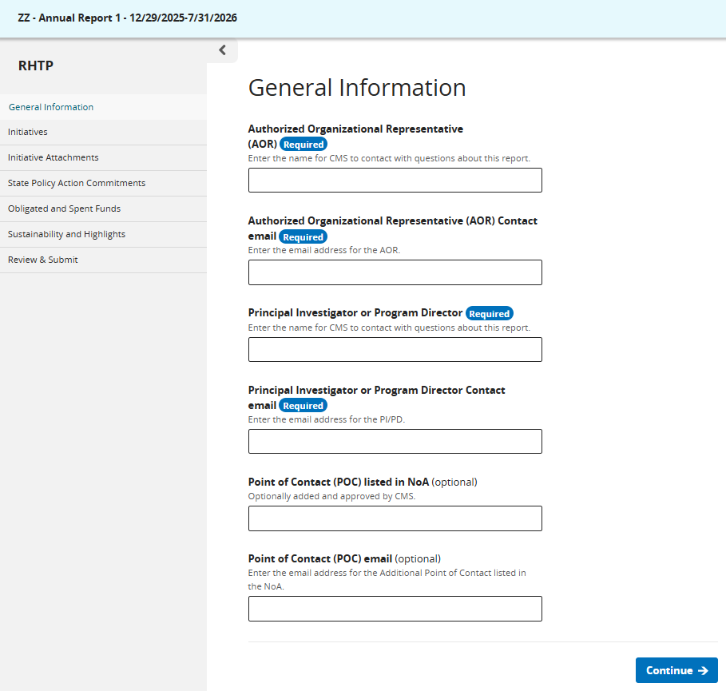
Figure 3 below displays the relevant data fields on the General Information page, followed by instructions and example values for completing each field. Please note, the examples are notional and should only be used as a guide.
Figure 3: General Information Instructions
Data Field | Instructions | Example
Authorized Organizational Representative (AOR) | Enter person’s name or a position title for CMS to contact with questions about this report. | Jane Smith
Authorized Organizational Representative (AOR) Contact email | A department or program-wide email address is acceptable. | JaneSmith@state.gov
Principle Investigator or Program Director | Enter person’s name or a position title for CMS to contact with questions about this report. | John Williams
Principle Investigator or Program Director Contact email | A department or program-wide email address is acceptable. | JohnWilliams@state.gov
Point of Contact (POC) listed in the NoA (Optional) | Optionally added and approved by CMS. | Jane Doe
Point of Contact email (Optional) | Enter the email address for the additional POC listed in the NoA. | Jane Doe@state.gov

Initiatives
This section is pre-populated based on State-reported information from the initial Annual Report, displaying each initiative's name and number. To submit updates for the current reporting period, select "Edit" next to the corresponding Initiative as shown below in Figure 4.
Figure 4: Initiatives
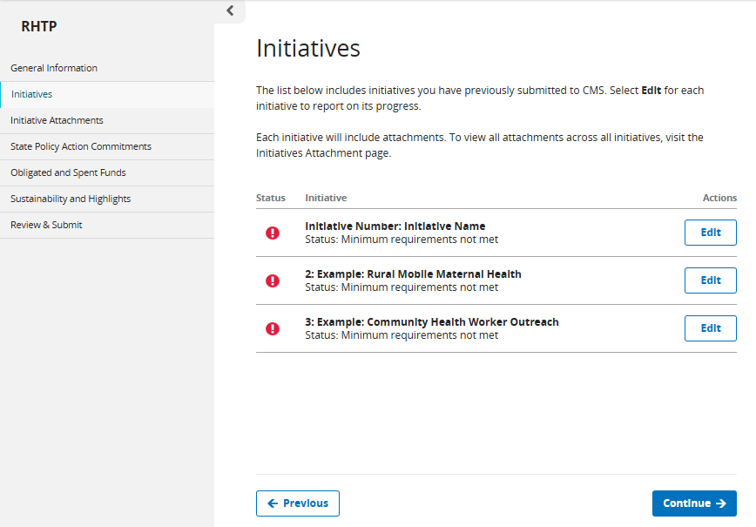

Figures 5, 6, 7, and 8 below display the Initiatives reporting section, including fields for entering a narrative summary, updating performance metrics, and managing checkpoint status and attachments.
Figure 5 below displays the fields where States enter their narrative summary and the number of people served. Both fields are required for the Annual Report and optional for the Quarterly Report.
The “Number of People Served” field is included to better understand the number of individuals who have benefited from the RHT Program funds during the reporting period. This number is separate from metrics and does not impact annual rescoring. This element is intended to help demonstrate the anticipated reach and impact of the initiative and, over time, help tell the story of how RHT Program investments are affecting rural communities. For purposes of this reporting field, “benefited” should not be interpreted as a broader or separate category from “served.” Rather, the terms are being used synonymously for purposes of the existing Number of People Served field.​
Figure 5: Initiative Number/Name
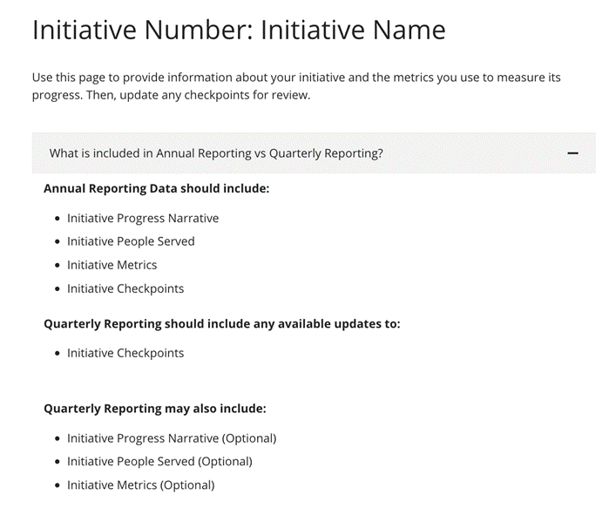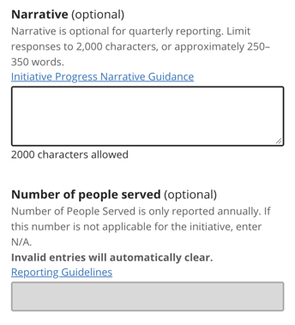

Figure 6: Tracking Initiative Performance Metrics

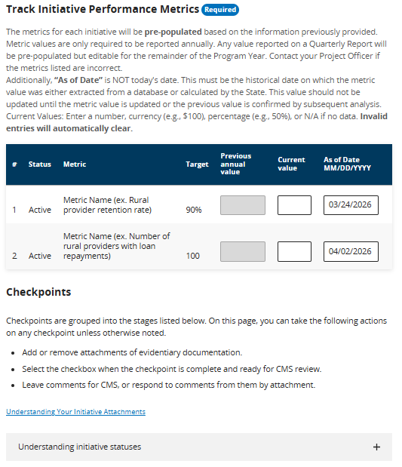

Within the Metrics table in Figure 6 above, the metrics values for each initiative will be pre-populated starting Quarterly Report #1 based on information previously provided. The metric values will carry over automatically from quarter to quarter, allowing for modifications as needed. States are only required to report metric values annually. Metric reporting fields can be updated throughout the year until each Annual Report is due. States should reach out to their PO if they have questions about their pre-populated metrics. CMS is working to get the target values prepopulated in MDCT.
Figures 7 and 8 below display the checkpoint stages page within MDCT, where States can upload attachments and mark these as ready for review by CMS for POs to iteratively review and provide feedback as States progress. States can attach evidentiary documentation on this page by selecting “Upload Attachments,” or on the following page, Initiative Attachments (below).
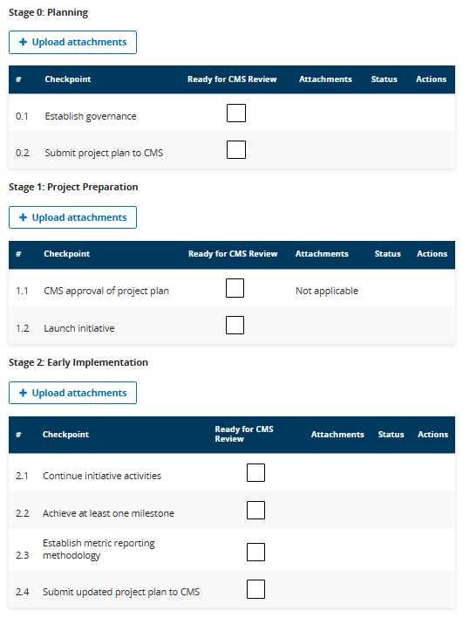
Figure 7: Checkpoint Stages 0 - 2

Figure 8: Checkpoint Stages 3-5
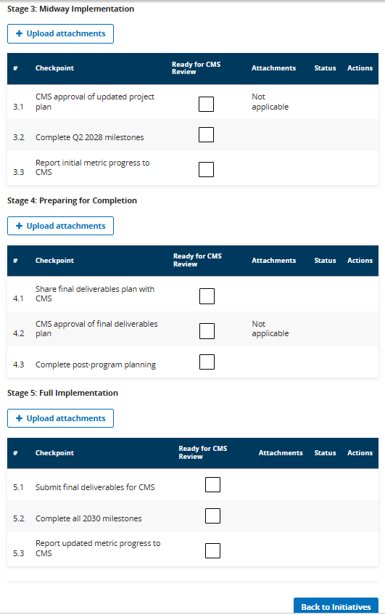

Figure 9 below includes the relevant data fields in the Initiatives section, instructions for how to fill out each data field, and an example data value for each field. Please note, the examples are notional and should only be used as a guide.
Figure 9: Initiative Progress Instructions
Data Field | Instructions | Example
Narrative | Provide a concise update on the progress of each initiative during the reporting period. Responses should focus on key activities completed, milestones reached, challenges encountered, and any notable outcomes or impacts to date.  This section is intended for progress reporting purposes only and should not repeat the full project narrative from the NCC Kit. Please focus on recent initiative progress and avoid including broad background information unless it is necessary for context.  States are encouraged to include any relevant updates that may be important for CMS to understand the status, implementation progress, or emerging results of the initiative.  Note: Initiative Progress Narrative is only required to be reported in the Annual Report and is optional for Quarterly Reports.  Please limit responses to 2,000 characters, or approximately 250–350 words. | Over the past year, we deployed five fully equipped Mobile Maternity Clinics across 12 of our most underserved counties, effectively eliminating geographic barriers to care. This proactive approach has enabled us to deliver over 2,500 prenatal and postpartum visits directly to expectant mothers, driving a 40% increase in first-trimester care initiation. By integrating satellite-enabled telehealth for high-risk specialist consultations and employing local community health workers to build trust, we have not only expanded essential access but fundamentally transformed the maternal health infrastructure for our rural populations.
Number of People Served | Provide best estimate of the number of individuals who have benefited from RHT Program funds during the reporting period.  Estimates should be reasonable, supported by available data, and reflect the scope and reach of the initiative.  The number of people served should report the current period reach, not future projections. If States have the number of people who have been served already, then they should report the number of people who have been served already for the initiative by the end of the reporting period.  If no individuals were served/benefitted during the reporting period, report 0 rather than a projection of future reach. A reported value of zero (0) for Year 1 is fully anticipated and acceptable, particularly where initiatives remain in Stage 0 – Planning or Stage 1 – Project Preparation.​ N/A is not an acceptable response as each initiative is expected to serve or benefit individuals at some point during the RHT Program.  For system-based initiatives that do not provide direct services (e.g., IT systems, Health Information Exchanges), States may define the number of people served more broadly.  For example:  - For health system–level initiatives, the number served may reflect the total population served by the system.  - For statewide systems (e.g., HIEs), the number served may reflect the number of patients with data in the system or the total number of state residents.  - These estimates do not need to be de-duplicated and do not need to be limited to rural populations if the initiative has a broader reach.  - States should aim to provide the most accurate and justifiable estimate possible and may include brief context in the narrative section if helpful for CMS’s understanding.  Note: Number of People Served is only required to be reported in the Annual Report and is optional for Quarterly Reports. | 500
Metric | The metric for each initiative will be pre-populated based on the information previously submitted.  Note: Initiative Metrics are only required to be reported in the Annual Report and are optional for Quarterly Reports.
Status | Metric status will be displayed with the following potential statuses:  - Active  - Abandoned  This field is read-only for States and can only be updated by CMS. | Active
Target | Target values will be pre-populated and will be updated based on States’ information from previous reports. This field is read-only for States and can only be updated by CMS. | 90
Previous Annual Value | Previous Annual Report values that States have reported will be displayed. This field is read-only for States and can only be updated by CMS. | 5
Current Value | Enter the current value of each metric relevant to the reporting period.  Note: The Current Value field is only required to be reported in the Annual Report and is optional for Quarterly Reports. | 90
As of Date (MM/DD/YYYY) | Enter the ‘as of date’ of the metric.  The “As of Date” column should be populated to reflect the date on which the State measured or analyzed the data being reported for the applicable reporting period. Examples may include: ​  - The date a contractor reported metric values to the State​  - The date a State pulled data from their data systems​ | 04/19/2026

Initiative Attachments
This section prepopulates the attachments, initiatives, checkpoints, and statuses previously entered on the Initiatives page. Depending on the attachment's status, States may add, edit, or delete these files, as well as add or respond to comments from their POs.
If an attachment applies to multiple initiatives (such as a single project plan or metric methodology file), States can upload it once to the general Initiative Attachments page. This page accepts both informational attachments and those intended for rescoring. Both informational attachments (attachments for reference purposes only) and attachments intended for rescoring may be submitted on this page shown below (Figure 10).
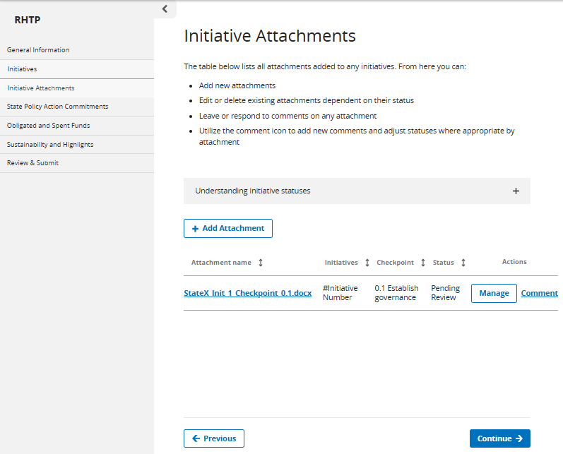
Figure 10: Initiative Attachments

The page also includes guidance defining the various Attachment Statuses and review stages, including:
- Pending Review (System Automated): This status is applied automatically when a new attachment is added. It lets CMS know the document is ready to be reviewed. While in this status, if no comments have been made, full editing power is retained by the State, and the file can be deleted or swapped freely.
- Needs Revision (CMS Project Officer): A reviewer selects this status when a document requires updates or corrective context before it can be formally approved. CMS uses this status when a document needs updates or corrections from the State. This status may be utilized during the iterative checkpoint review process that may take place prior to a quarterly/annual reporting deadline. Please review CMS feedback and upload a revised version as needed.
  - Example A: The PO may provide feedback via comment within the MDCT RHTP platform to the State on a piece of evidence submitted for a checkpoint that needs additional information to be considered “Accepted.”
- Informational (CMS or State User): CMS or the State may use this status for documents that are for reference only. These documents are not used for scoring. Once selected, the file is locked from deletion, so it remains a permanent part of a State’s record-keeping history.
  - Example A: A State may use this status to classify a PO's email approval as “informational only."
  - Example B: A State may use this status to maintain an updated Project Plan throughout the program.
- Archived (CMS or State User): This status allows hiding older, outdated file versions from the active workspace view without purging them from the historical audit trail. CMS or the State may use this status for documents that are no longer part of the active submission but should be kept for records. Archived documents will not carry over from one report to the next.
  - Example A: A State may classify a previously uploaded attachment as 'archived' if they are replacing it with a more recent piece of evidence.
  - Example B: The PO may determine a piece of evidence does not meet the checkpoint criteria (aka is “rejected”) so the evidence should be moved to ‘archived’ status.
- "Locked for Scoring (CMS Admin Only): Assigned by CMS when a record is undergoing formal review and scoring; content is locked in a read-only state and cannot be modified or deleted. States have been advised throughout the reporting process to work with their PO in advance of reporting deadlines to resolve questions and reach alignment between the State and PO. ‘Locked for Scoring’ is ideally the status after the State and PO have aligned with what is “acceptable.”
Relevant Initiative Actions
1. Uploading an attachment
To upload evidentiary documentation, select “+ Add Attachment” located below the ‘Understanding Initiative Statuses’ section as illustrated in Figure 9 above. A pop-up window will display checkboxes to designate which initiatives the file applies to. Below these checkboxes, use the dropdown menu to select the corresponding stage/checkpoint, as displayed in Figure 11 below.
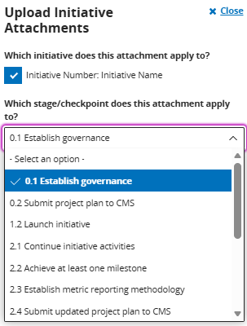
Figure 11: Upload Initiative Attachments Dropdown Menu

After selecting the corresponding initiative and checkpoint, if applicable, select a file or files to upload as evidentiary documentation for the corresponding checkpoint, as shown in Figure 12 below.

Figure 12: Upload Initiative Attachments
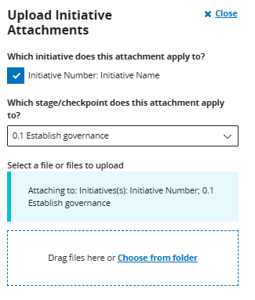

2. Adding a comment to an attachment
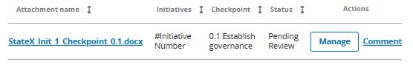
If a State needs to communicate with their PO regarding a specific file, they can utilize the optional commenting feature. On the Initiative Attachments dashboard, select “Comment” next to the relevant attachment to enter and submit remarks, shown in Figure 13 below.
Figure 13: Add Comments to Attachments

Once the comment feature is selected, States will be directed to the screen below, in Figure 14, where they can enter comments. States should use this function to share evidence with the PO for review and feedback. This step is optional, not an official submission, and only for the purposes of iterating with the PO before later selecting “Submit RHTP Report.” To allow ample time for review and feedback, States are advised to work with their PO in advance of the deadline to resolve questions and reach alignment on the progress they intend to report and ensure what the State ultimately submits is acceptable.
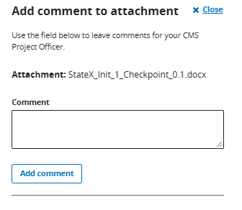
Figure 14: Add Comments to Attachments

3. Editing attachments
To update attachment files or the initiative(s) or checkpoint(s) the attachment applies to, select “Manage” in the Actions column. States can select or deselect the initiatives to indicate where the attachment applies. Selecting “Manage” from the Actions column will list the applicable initiatives. From this interface, States have the option to modify their status. Actions can also be taken to delete the file or align it to the respective checkpoint as illustrated by Figures 15-17 below.
Figure 15: Managing Attachments
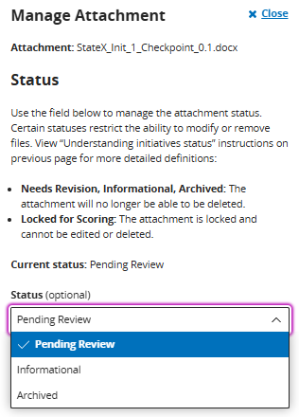

Figure 16 below displays the screen on which States can select which initiative and stage/checkpoint their attachment applies to.
Figure 16: Managing Attachments (Continued)
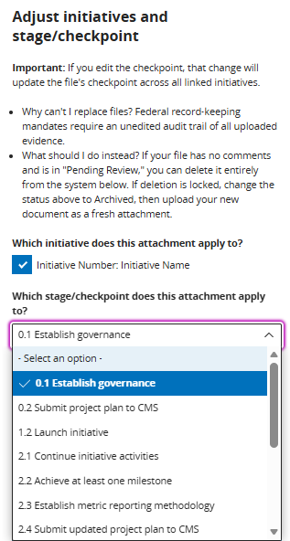

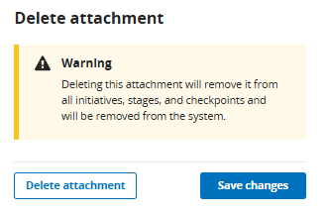
Figure 17: Deleting Attachments
Figure 17 above displays the warning States will receive upon choosing to delete an attachment. States’ ability to delete an attachment is dependent on the attachment’s status. An attachment cannot be deleted if it is locked for scoring or in “Needs Revision, Informational, or Archived.” An erroneous file may only be deleted while it is in ‘Pending Review’ status and has no associated comments. Once an attachment has been reviewed, modified, or commented on, deletion is disabled and the file status must be designated as “Archived”.

4. Viewing an attachment’s comments
In the Actions column, as shown in Figure 18, select “Comment” to view a historical log of comments associated with the selected attachment.
Figure 18: Viewing Attachment Comments
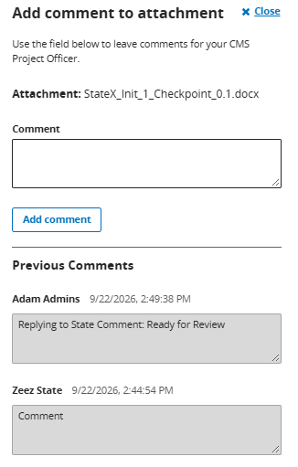

State Policy Action Commitments
The page below, as displayed in Figure 19, lists any State Policy Action Commitments as outlined in the State’s approved application. Each commitment can be expanded to update its status, evidence, and comments for the current reporting period.
Only official legislation links and attachments are recognized as valid evidence to demonstrate progress toward the fulfillment of a policy commitment. Promotional content, such as press releases and marketing links, will not be accepted as sufficient evidence. The “CMS Status Evaluation” field will be prepopulated with CMS’ evaluation of that specific State Policy Action Commitment
from the initial Annual Report. States cannot edit this field.
Figure 19: State Policy Action Commitments
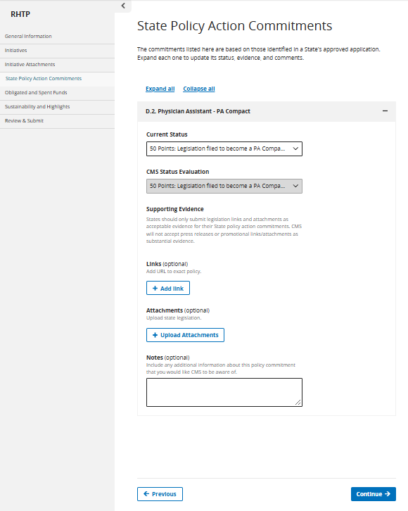
Figure 20 below outlines the relevant data fields on the State Policy Action Commitments page, along with instructions for completing each field and illustrative example values, where applicable. Please note, the examples are notional and should only be used as a guide.
Figure 20: State Policy Action Commitments Page Instructions
Data Field | Instructions | Example
Current Status | Select from the dropdown the corresponding status/updates for each commitment during the reporting period.  Please note that each dropdown menu is specific to the selected technical score factor (D.2., D.3., etc.). | 50 Points: Legislation filed to become a PA Compact (Technical Score Factor D.2).
Supporting Evidence: Links | Provide link(s) to State legislation that validates the current status of the State Policy Action Commitment. | Link to the exact policy.
Supporting Evidence: Attachments | Upload State legislation attachment(s) that validates the status of the State Policy Action Commitment. | State Legislation attachment and/or URL.
Notes and Comments | Provide any additional context or details around the status of the State Policy Action Commitments, if needed. If possible, in the notes section, please highlight the exact section of the legislation that corresponds to the State Policy Action Commitment status change. | The bill was signed into law on July 15, 2026, and becomes effective January 1, 2027.

Obligated and Spent Funds Reporting
Refer to the Obligated and Spent Funds Reporting Guide for detailed instructions on completing these forms. Complete the Obligated and Spent Funds Excel template and upload the file directly by selecting “+ Add Obligated and Spent Funds”, as demonstrated in Figure 21 below.
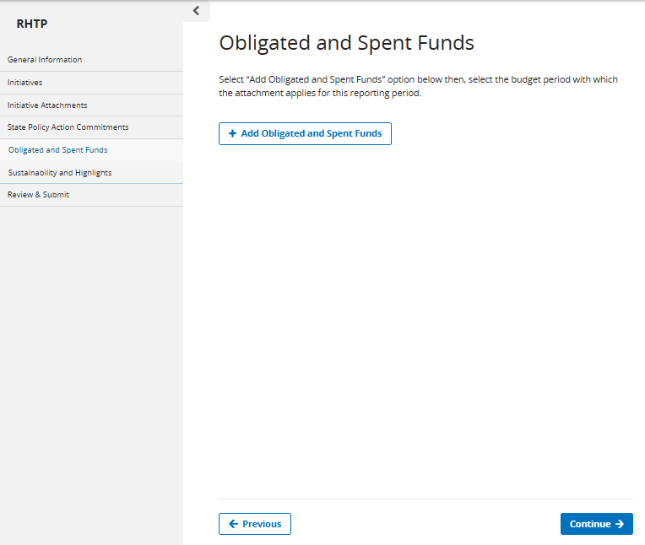
Figure 21: Obligated and Spent Funds
Figures 22 and 23 below display the interface States can use to upload their Excel template(s) for the respective reporting period and select the relevant budget period for that specific file.
Figure 22: Obligated and Spent Funds File Upload

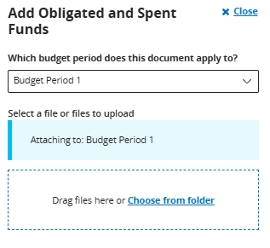

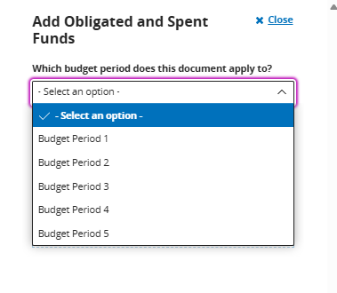
Figure 23: Add Obligated and Spent Funds

Sustainability & Highlights
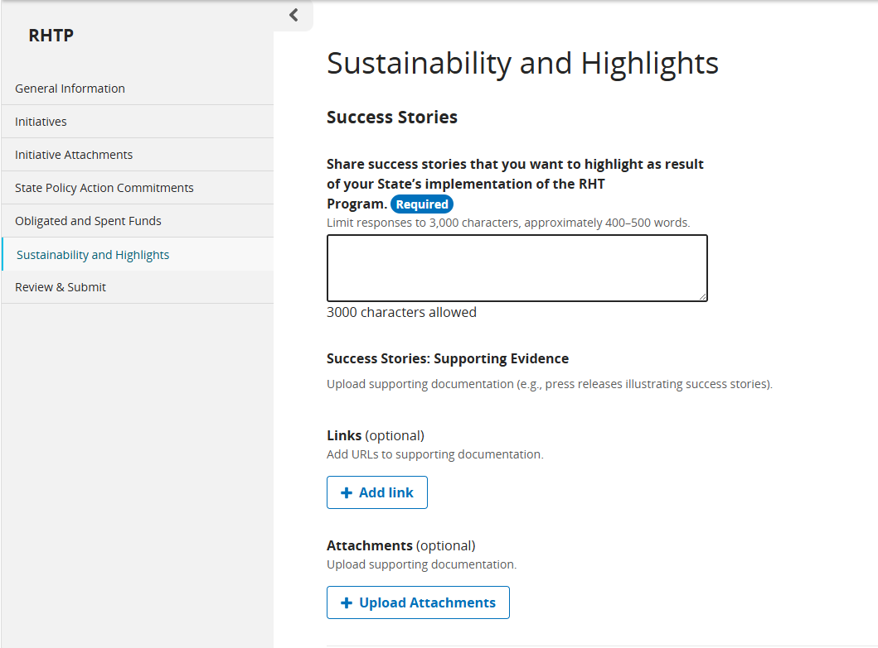
On this page, Sustainability and Highlights, qualitative updates on program successes and long-term sustainability planning may be shared. Note that Sustainability and Highlights submissions are open quarterly but are only required annually. Figure 24 displays the corresponding data entry fields from the Annual Report view.
Figure 24: Sustainability and Highlights

Figure 25 below displays where States can enter updates pertaining to their sustainability plans and supporting documentation.

Figure 25: Sustainability Planning

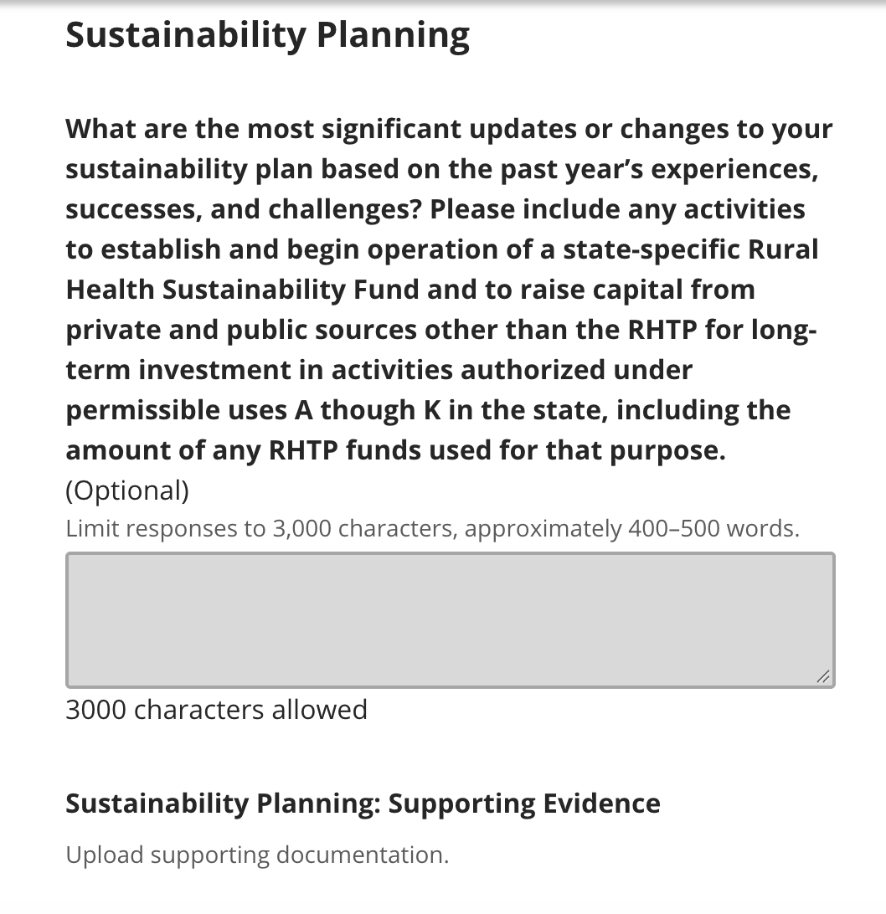
Figure 26 below outlines the relevant data fields of the Sustainability and Highlights page, along with instructions for completing each field and illustrative example values, where applicable. Please note, the examples are notional and should only be used as a guide.
Figure 26: Sustainability and Highlights Page Instructions
Data Field | Instructions | Example
Success Stories | Share success stories that you want to highlight as a result of your State’s implementation of the RHT Program.  Please limit responses to 3,000 characters, approximately 400–500 words. | In a rural community with no local obstetrician, our new mobile health clinic (Initiative 1) provided prenatal care to 45 expectant mothers. One patient was able to receive all her prenatal checkups locally, avoiding a 3-hour round trip to the nearest city. This consistent care led to the early detection of a complication, ensuring a healthy delivery for both mother and baby.
Sustainability Planning | What are the most significant updates or changes to your sustainability plan based on the past year’s experiences, successes, and challenges?  Please include any activities to establish and begin operation of a state-specific Rural Health Sustainability Fund and to raise capital from private and public sources other than the RHTP for long-term investment in activities authorized under permissible uses A though K in the state, including the amount of any RHTP funds used for that purpose.  Please limit responses to 3,000 characters, approximately 400–500 words. | Based on the high demand for the mobile clinic, we have initiated discussions with the State Medicaid agency to establish a permanent reimbursement pathway for mobile health services. Furthermore, we have secured a partnership with the State University's nursing school to create a clinical rotation program on the mobile unit, which will provide a sustainable staffing pipeline and reduce future personnel costs.

Review & Submit
On this final page, as shown below in Figure 27, all previously entered report information is displayed for review prior to submission. Carefully review all components to ensure accuracy and completeness. A warning label will indicate if errors or missing required responses have been detected.
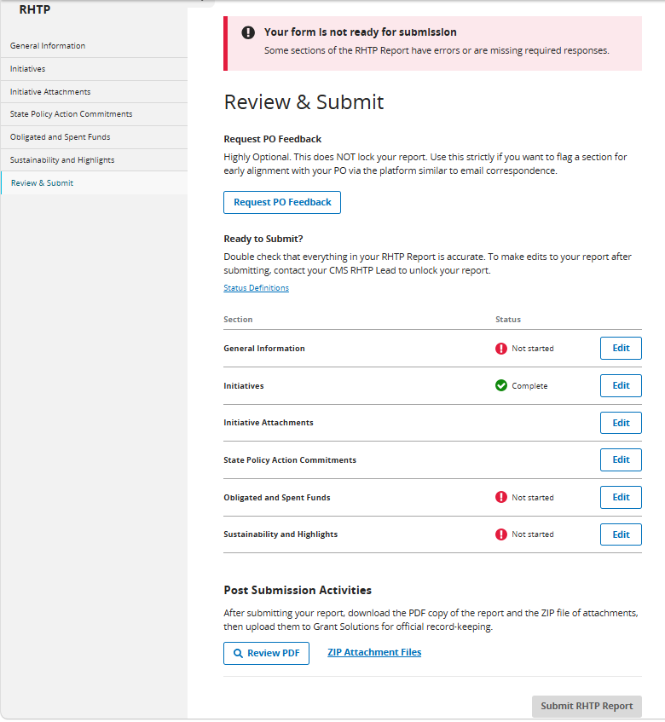
Figure 27: Review and Submission
Two submission actions are available within the system:
- Request PO Feedback: Selection of this option, as displayed in Figure 28 below, permits a draft report to be shared with the PO for review and feedback. States should use this function to share evidence with the PO for review and feedback. This step is optional, not an official submission, and only for the purposes of iterating with the PO before later selecting “Submit RHTP Report.” To allow ample time for review and feedback, States are advised to work with their PO in advance of the deadline to resolve questions and reach alignment on the progress they intend to report and ensure what the State ultimately submits is acceptable. Optional comments may be included to communicate specific elements needing attention. Editing capabilities remain active while in review. States will then be notified once their PO has completed the feedback request.
- Example A: “Hello PO, the evidence for the B.4. State Policy Action is ready for preliminary review, please let us know if you have any questions.”
- Example B: "Hello PO, would you mind taking a look at our evidence for Checkpoints 2.4, 3.2, and 3.3 as well as State Policy Actions B.4 and C.3. Let us know if you have any feedback or if it’s ready to submit.”
Figure 28: Request PO Feedback
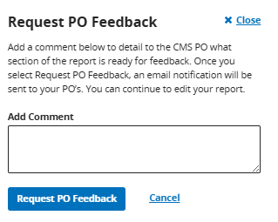

- Submit RHTP Reports
  - Upon formal submission of the report, States should check that all data entries within the report are complete and accurate. On the Review and Submit page, the Status column displays the completion state of each section. To review specific criteria and explanations for each designation, select “Status Definitions,” as displayed in Figure 29 below.
Figure 29: Status Definitions
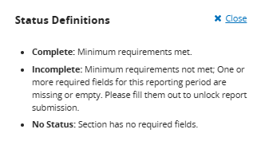
  - Following the review and verification of all required data, States may proceed to formally submit the completed report.
  - Upon selecting “Submit RHTP Report” States will be prompted with a confirmation window to verify their submission. Once confirmed, the report transitions to a locked, read-only state and cannot be modified for the remainder of the reporting period. Beginning with the first quarterly progress report, all Annual and Quarterly Reports must be formally submitted via this action in MDCT prior to the reporting deadline.
Figure 30: Submission Confirmation
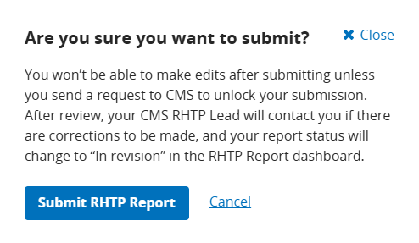
After submission via the MDCT RHTP platform and acceptance by CMS, States may export the reporting package as a PDF download, including all submitted data and evidentiary documentation platform as a Zip file for recordkeeping.
Following its review, CMS will upload the report as submitted in MDCT to GrantSolutions on the State’s behalf for the official record. The State must not separately submit these quarterly or annual progress report materials to GrantSolutions. Reporting materials submitted outside the MDCT RHTP platform, including directly to GrantSolutions, will not be considered for CMS review or scoring.

Appendix

A. Annual and Quarterly Reporting Periods
Figure 31: Reporting Periods
Report | Reporting Period Start Date | Reporting Period End Date | Due Date
Budget Period 1: December 29, 2025, to October 30, 2026 (10 months)
Annual Report # 1 | December 29, 2025 | July 31, 2026 | August 31, 2026*
Quarterly Report # 1 | August 1, 2026 | October 30, 2026 | November 30, 2026*
Budget period 2: October 31, 2026, to October 30, 2027
Quarterly Report # 2 | October 31, 2026 | January 30, 2027 | March 1, 2027
Quarterly Report # 3 | January 31, 2027 | April 30, 2027 | June 1, 2027*
Annual Report # 2 | August 1, 2026 | July 31, 2027 | August 30, 2027
Quarterly Report # 4 | August 1, 2027 | October 30, 2027 | November 29, 2027
Budget period 3: October 31, 2027, to October 30, 2028
Quarterly Report # 5 | October 31, 2027 | January 30, 2028 | February 29, 2028
Quarterly Report # 6 | January 31, 2028 | April 30, 2028 | May 30, 2028
Annual Report # 3 | August 1, 2027 | July 31, 2028 | August 30, 2028
Quarterly Report # 7 | August 1, 2028 | October 30, 2028 | November 29, 2028
Budget period 4: October 31, 2028, to October 30, 2029
Quarterly Report # 8 | October 31, 2028 | January 30, 2029 | March 1, 2029
Quarterly Report # 9 | January 31, 2029 | April 30, 2029 | May 30, 2029
Annual Report # 4 | August 1, 2028 | July 31, 2029 | August 30, 2029
Quarterly Report # 10 | August 1, 2029 | October 30, 2029 | November 29, 2029
Budget period 5: October 31, 2029, to October 30, 2030
Quarterly Report # 11 | October 31, 2029 | January 30, 2030 | March 1, 2030
Quarterly Report # 12 | January 31, 2030 | April 30, 2030 | May 30, 2030
Annual Report # 5 | August 1, 2029 | July 31, 2030 | August 30, 2030
Quarterly Report # 13 | August 1, 2030 | October 30, 2030 | November 29, 2030
Final Report | December 29, 2025 | October 30, 2030 | February 27, 2031

Please note: Deadlines falling on a weekend and/or holiday will extend to the next business day. The following deadlines have been updated and are marked with an asterisk in the table above: Annual Report #1 (deadline extended to August 31, 2026), Quarterly Report #1 (deadline extended to November 30, 2026), and Quarterly Report #3 (deadline will extend to June 1, 2027).

B. Resources
For additional information on RHT Program reporting, please refer to the resources below.
- Rural Health Transformation (RHT) Program | CMS
- Rural Health Transformation FAQ

C. State Progress Reporting Frequently Asked Questions (FAQs)
Below are FAQs that cover the Annual and Quarterly Reports, reporting submission process, evidentiary documentation, and State reporting noncompliance.

Reporting Submission Process
- How should States submit Annual Reports?
  - During the initial program year (covering a 10-month period from 12/29/25 – 7/31/26), States received a standardized Excel Reporting Template to complete the first Annual Report (due August 31, 2026). For all subsequent reporting, the program will transition to a web-based interface. The platform will be deployed prior to the first quarterly reporting deadline. States will input reporting information into the MDCT RHTP platform for iteration with the PO.
- Will there be iteration between PO and State before or after each reporting deadline?
  - To allow ample time for review and feedback, States are advised to work with their PO in advance of the deadline to resolve questions and reach alignment on the progress they intend to report and ensure what the State ultimately submits is acceptable. States that do not take advantage of the advance review process may risk submitting evidence that CMS may “Reject.”
  - The PO may accept the State’s evidence, request additional information or clarification, or determine with the State that a different level of progress has been achieved. States should use the outcome of that review to prepare their final submission.
  - CMS does not plan to return to States after the reporting deadline for additional clarification or substantive iteration on checkpoint or State Policy Action evidence. This is consistent with the approach used during the application process.
- Will States have the opportunity to revisit the target and target completion date after reporting the baseline?
  - States will be able to change targets and target completion dates up until Checkpoint 3.3 (Report Initial Metric Progress to CMS). After this Checkpoint, States should only change targets and target completion dates due to extenuating circumstances. To submit Checkpoint 3.3, “Report Initial Metric Progress to CMS,” States must first have established baselines and targets to be able to report progress against them.
Evidentiary Documentation
- Do States have to provide evidentiary documentation?
  - Yes, States are required to provide evidentiary documentation for each of the initiative checkpoints completed and for progress indicated for State Policy Action Commitments. However, there is an exception for checkpoints 1.1 and 3.1 as those are automatically reviewed upon submission of 0.2 and 2.4.
  - The type of evidentiary documentation that States should submit will vary depending on the checkpoint. Please refer to the Checkpoint Guidance tab in the first Annual Report Excel.
- How should States compile evidentiary documentation?
  - Please refer to Submitting Evidentiary Documentation section for more information and examples of acceptable evidentiary documentation.

State Reporting Non-Compliance
- What does it mean if a State fails to submit required reports?
  - Per the Program Terms and Conditions, failure to submit required reports is considered a violation of the terms of the Cooperative Agreement.
- Is there an opportunity for States to address non-compliance before further action is taken?
  - Yes. Per the Program Terms and Conditions, States will be issued a notice of non-compliance and provided a 90-day remediation period to correct the identified issues.
- What actions may CMS take if non-compliance is not remedied within the remediation period?
  - If non-compliance is not resolved, CMS reserves the right to take one or more of the following actions as stated in the Program Terms and Conditions:
    - Recover previously issued payments.
    - Withhold future payments, including both workload and baseline funding.
- Can non-compliance result in suspension or termination of the award?
  - Yes. Per the Program Terms and Conditions, significant performance issues—such as misuse of funds or failure to carry out approved activities—may result in suspension or termination of the award. In such cases, the State would be ineligible for further funding until the non-compliance is resolved.
  - Per the Program Terms and Conditions, at any time, CMS can decrease funding, recover funding, or terminate an award if a State fails to fulfill the requirements of the award. The award may also otherwise be terminated to the extent authorized by law, if the agency determines the award no longer effectuates program goals or agency priorities.

D. Getting Started – Submitting the Initial Annual Report
To facilitate a timely and accurate initial Annual Report submission, States should coordinate closely with their Project Officers (POs) to establish an ongoing, rolling review of the report's various components. Because revisions cannot be accommodated after the August 31st, 2026 submission deadline, this continuous collaboration is critical to confirm that all elements are finalized, reviewed, and approved in a timely manner.
In the initial Annual Report, States are to provide the definition of 'rural area' that the State used to determine whether subrecipients were considered to be rural. States will use this same definition to determine rural entities throughout the duration of the RHT Program, therefore, the definition does not need to be included in subsequent reporting. States will report their definition of rural in the Additional Information Form.
For example, in this field, a State may report that they define rural using the following definition from the Health Resources & Services Administration (HRSA):
- Non-metropolitan counties
- Outlying metropolitan counties with no population from an urban area of 50,000 or more people
- Census tracts with Rural-Urban Commuting Area (RUCA) codes 4-10 in metropolitan counties
- Census tracts of at least 400 square miles in area with population density of 35 or fewer people per square mile with RUCA codes 2-3 in metropolitan counties

Instructions
The Excel Reporting Template is organized into four core sections:
- Initiative Reporting Section
  - Checkpoint Guidance Tab
  - Initiative Forms
- State Policy Actions Form
- Obligated and Spent Funds Reporting Section
  - Entity Type Guidance Tab
  - First-Tier Entities Form
  - Use of Funds Form
  - Downstream Reporting Form
- Additional Information Form
  - Success Stories
  - Sustainability Planning
  - Rural Definition
Important Formatting Note: Please do not alter the underlying structure of the Excel Reporting Template, though States may adjust row heights and column widths for readability. To streamline reporting, CMS will pre-populate certain fields—such as Initiative Name and Initiative Number in the Initiative Forms—based on the State’s approved application. Please note that all forms (tabs), with the exception of the Downstream Reporting Form, must be fully completed for the initial Annual Report to be considered final. The Downstream Reporting Form will be required starting with the first Quarterly Report.
Alongside the Excel Reporting Template, States should submit all supporting evidentiary documentation directly to their PO for review, via email, to accompany the initial Annual Report. This submission should include any files demonstrating progress toward initiative checkpoints and State Policy Action Commitments. See the Submitting Evidentiary Documentation section below for more information. All forms (tabs) must be completed, with the exception of the Downstream Reporting Form, for the submitted initial Annual Report to be considered final.
The sections below provide additional details for each of the four main components of the Excel Reporting Template.

Initiative Forms
The purpose of the Initiative Forms is to report on the progress, metrics, and checkpoint completion for each approved State initiative.
In the Excel Reporting Template, there will be a separate Initiative Form (tab) for each initiative. Figures 32 and 33 below show a draft Initiative Form completed with a hypothetical example to illustrate the required information.
Figure 32: Initiative Form (Top)
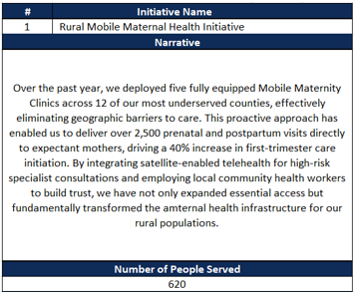
Figure 33: Initiative Form (Bottom)
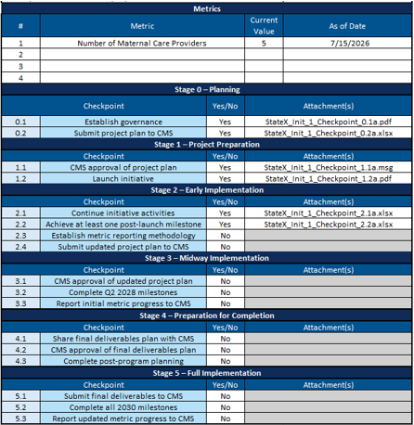

Figure 34 below includes the relevant data fields in the Initiative Form, instructions for how to fill out each data field, and an example data value for each field. Please note, the examples below are notional and should only be used as a guide.
Figure 34: Initiative Form Instructions
Data Field | Instructions | Example
Initiative Number | This field will be pre-populated in the Excel Reporting Template. | 1
Initiative Name | This field will be pre-populated in the Excel Reporting Template. | Rural Maternal Mobile Health Clinic Initiative
Narrative | Provide a concise update on the progress of each initiative during the reporting period. Responses should focus on key activities completed, milestones reached, challenges encountered, and any notable outcomes or impacts to date.  This section is intended for progress reporting purposes only and should not repeat the full project narrative from the NCC Kit. Please focus on recent initiative progress and avoid including broad background information unless it is necessary for context.  States are encouraged to include any relevant updates that may be important for CMS to understand the status, implementation progress, or emerging results of the initiative.  Note: The Narrative is only required to be reported in the Annual Report and is optional for Quarterly Reports.  Please limit responses to 2,000 characters, or approximately 250–350 words. | Over the past year, we deployed five fully equipped Mobile Maternity Clinics across 12 of our most underserved counties, effectively eliminating geographic barriers to care. This proactive approach has enabled us to deliver over 2,500 prenatal and postpartum visits directly to expectant mothers, driving a 40% increase in first-trimester care initiation. By integrating satellite-enabled telehealth for high-risk specialist consultations and employing local community health workers to build trust, we have not only expanded essential access but fundamentally transformed the maternal health infrastructure for our rural populations.
Number of People Served | Provide your best estimate of the number of individuals who have benefited from the RHT Program funds during the reporting period. Estimates should be reasonable, supported by available data, and reflect the scope and reach of the initiative. For system-based initiatives that do not provide direct services (e.g., IT Systems, Health Information Exchanges) States may define the number of people served more broadly.  For example:  - For health system–level initiatives, the number served may reflect the total population served by the system.  - For statewide systems (e.g., HIEs), the number served may reflect the number of patients with data in the system or the total number of state residents.  - These estimates do not need to be de-duplicated and do not need to be limited to rural populations if the initiative has a broader reach.  - States should aim to provide the most accurate and justifiable estimate possible and may include brief context in the narrative section if helpful for CMS’s understanding.  Note: Number of People Served is only required to be reported in the Annual Report and is optional for Quarterly Reports. | 620
Metrics | The metrics for each initiative will be pre-populated based on the information provided in your application or most current information available based on clarifications in your Initiative Information Report.  Note: Metrics are only required to be reported in the Annual Reports and are optional to report in Quarterly reports.
Metric Current Value | The latest value for the corresponding metric. | 5
Metric As of Date | The date that the current value was measured in the following format: (XX/XX/XXXX). | 03/15/2026
Checkpoints | For each stage, the checkpoint number and description are pre-populated. | 0.1 Establish Governance
Yes/No | Select “Yes” if the checkpoint is complete; Select “No” if the checkpoint is not yet complete. | Yes
Attachment(s) | Paste in the attachment file names of the evidentiary documentation files that correspond to the relevant initiative and checkpoint.  Alternatively, States may compile evidentiary documentation into a Master Initiative Attachments PDF and reference the Initiative # and Stage/Checkpoint # section heading in the Master Initiative Attachments PDF. | StateX_Init_1_Checkpoint_0.1a.pdf  StateX_Init_1_Checkpoint_0.2b.xlsx  StateX_Init_1_Checkpoint_1.1c.msg  OR  “Initiative 1 Checkpoint 0.1 Evidentiary Documentation” section in the Master Initiative Attachments PDF

State Policy Action Commitments Form
The State Policy Action Commitments Form is designed to capture the progress and status of the specific policy commitments established in a State's approved application. Please note that States are only eligible to receive credit for policy actions committed to in their initial application.
Figure 35 below shows a draft State Policy Action Commitment Form completed with a hypothetical example to illustrate the required information. Please note, there are additional fields in a section titled “CMS Review (CMS Use Only)” in the State Policy Action Commitment Form (not pictured in Figure 34 below), which should not be populated by States.
Figure 35: State Policy Action Commitments Form
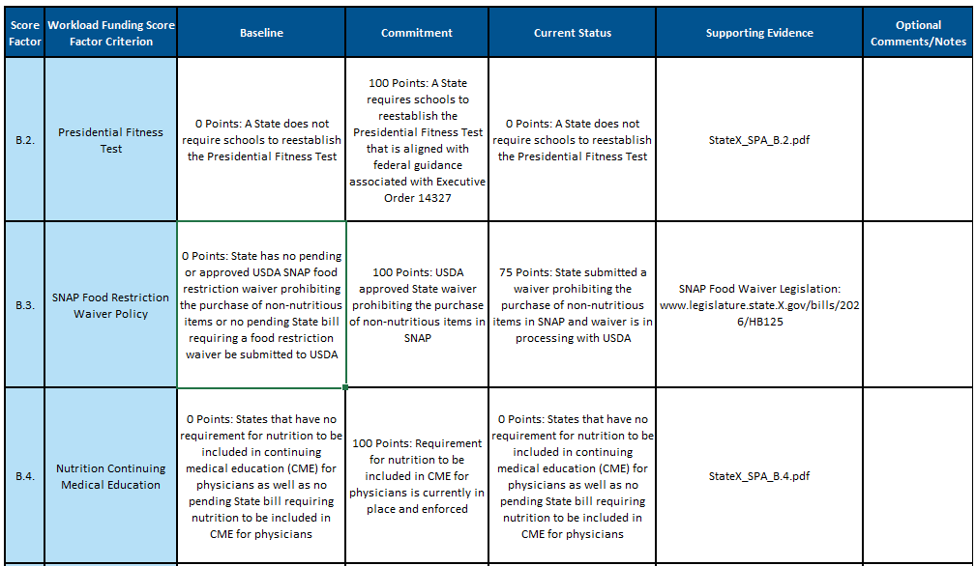
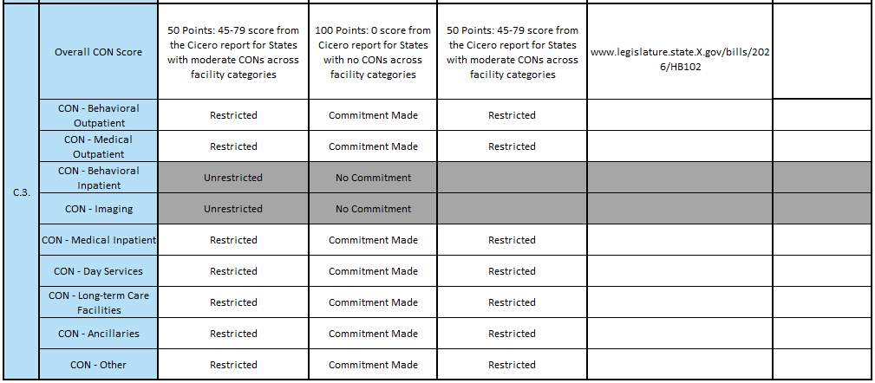
Figure 36 below outlines the data fields within the State Policy Action Commitment Form, along with specific instructions for completing each field and illustrative examples. Note: These examples are strictly notional and are provided solely for guidance.

Figure 36: State Policy Action Commitment Form Instructions
Data Field | Instructions | Example
Score Factor | This data field is pre-populated with the relevant score factor labels. | B.2.
Workload Funding Score Factor Criterion | This data field is pre-populated with the relevant score factor criterion. | Presidential Fitness Test
Baseline | This data field is pre-populated with a baseline value for each State Policy Action score factor. The baseline refers to the category of the baseline score for the State Policy Action score factor. | The baseline values are unique to each State Policy Action and will be consistent with the State's State Policy Action Commitment report. Examples include:  - No points (0)  - Partial points (1–99)  - Full points (100)
Commitment | This data field is pre-populated, and the value depends on if the relevant State Policy Action Commitment was made and approved by CMS. | If a State Policy Action Commitment was made in the application:  - Partial Points (1-99)  - Full points (100)  - Commitment Made  If a State Policy Action Commitment C was not made in application:  - No Commitment
Current Status | Select the current status from the dropdown menu (options reflect the scoring methodology in the NOFO and are dependent on the specific State Policy Action Commitment). If the State Policy Action Commitment was made, the Current Status cell for that Score Factor will appear white and the status can be indicated with the dropdown. If a State Policy Action Commitment was not made, the cell will be greyed out. | For State Policy Action Commitment B.3. (for example) dropdown options include:  - Not Yet Started  - 0 Points: No pending State legislation  - 25 Points: Active bill in the State legislative process  - 50 Points: State bill was passed to submit a USDA waiver  - 75 Points: Waiver is in processing with USDA  - 100 Points: USDA approved waiver  - Commitment abandoned  Note: Specific options will depend on each Score Factor.
Supporting Evidence | Provide any links to sources or attachments that confirm the status of the State Policy Action Commitment. | Examples may include:  - URL to policy on State website  - State legislation attachment
Optional Notes/Comments | Provide any additional context or details around the status of the State Policy Action Commitment, if needed. | The bill, titled “XYZ” was signed into law on July 15, 2026, and becomes effective January 1, 2027. See “Section 4 PA Licensure Compact” on Page 16 of the bill.

Obligated and Spent Funds Reporting Tabs
The purpose of the Obligated and Spent Funds Reporting tabs is to track RHT Program spending across initiatives, use of funds categories, and entities. Please refer to the Obligated and Spent Funds Reporting Guide for more information on how to populate the First-Tier Entities, Use of Funds, and Downstream Reporting tabs.

Additional Information Form
The purpose of the Additional Information Form is to share qualitative updates on program successes, long-term sustainability planning, and the definition of rural, as defined by the State. Figures 37, 38, and 39 below show the Additional Information Form completed with a hypothetical example to illustrate the required information.

Figure 37: Success Stories
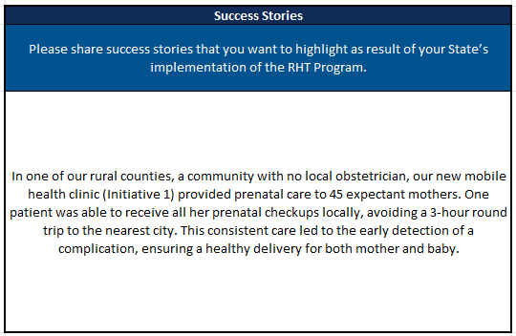

Figure 38: Sustainability Planning
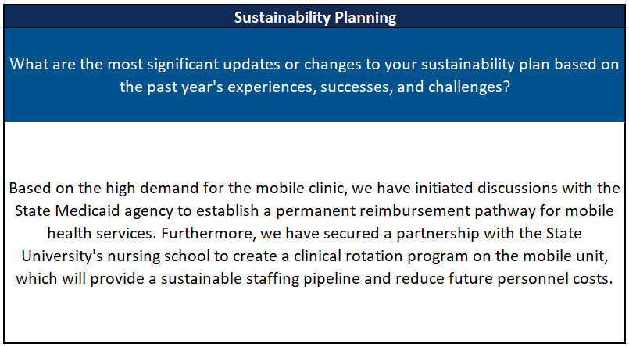

Figure 39: Rural Definition
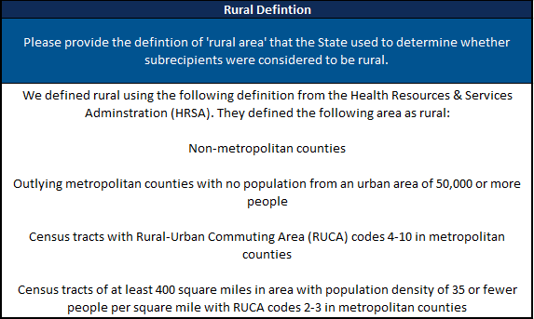
Figure 40 below outlines the data fields within the Additional Information Form, along with specific instructions for completing each field and illustrative examples. Note: These examples are strictly notional and are provided solely for guidance.
Figure 40: Additional Information Form Instructions
Data Field | Instructions | Example
Success Stories | Provide narrative example(s) of how the RHT Program has positively impacted rural communities in your State. Focus on specific, compelling stories that demonstrate the program's value.  Please limit responses to 3,000 characters, approximately 400–500 words. | In a [rural county] with no local obstetrician, our new mobile health clinic (Initiative 1) provided prenatal care to 45 expectant mothers. One patient was able to receive all her prenatal checkups locally, avoiding a 3-hour round trip to the nearest city. This consistent care led to the early detection of a complication, ensuring a healthy delivery for both mother and baby.
Sustainability Planning | Describe significant updates to your State's plan for continuing the program's impact after the grant period ends. This should be based on your experiences, successes, and challenges from the past year.  Please limit responses to 3,000 characters, approximately 400–500 words. | Based on the high demand for a mobile clinic, we have initiated discussions with the State Medicaid agency to establish a permanent reimbursement pathway for mobile health services. Furthermore, we have secured a partnership with the State University's nursing school to create a clinical rotation program on the mobile unit, which will provide a sustainable staffing pipeline and reduce future personnel costs.
Definition of Rural | Please provide the rural definition the State used to determine whether subrecipients were considered to be rural. | We defined rural using the following definition from the Health Resources & Services Administration (HRSA). They define the following areas as rural:  - Non-metropolitan counties  - Outlying metropolitan counties with no population from an urban area of 50,000 or more people  - Census tracts with Rural-Urban Commuting Area (RUCA) codes 4-10 in metropolitan counties  - Census tracts of at least 400 square miles in area with population density of 35 or fewer people per square mile with RUCA codes 2-3 in metropolitan counties

Submitting Evidentiary Documentation
For the initial Annual Report, States will submit all evidentiary documentation to their PO for review, via email. To allow ample time for review and feedback, States are strongly encouraged to provide documentation to their POs on a rolling basis prior to the final submission deadline.
Evidentiary documentation is only required for the following two components:
- Initiative Checkpoints: Documentation requirements vary depending on the specific checkpoint. States should provide evidence that directly corresponds to and demonstrates completion or progress for each individual checkpoint. Refer to the Checkpoint Guidance tab in the Excel Reporting Template for examples of acceptable evidence.
- State Policy Actions Commitments Form: For each State Policy Action Commitment for which there is an update in the Current Status, States must provide evidentiary documentation or a direct URL (e.g., a link to legislation, regulation, or a state register) that demonstrates progress toward the policy commitment. States may include a hyperlink directly within the Excel Reporting Template or submit a corresponding file.
To assist POs in understanding which pieces of evidentiary documentation apply to each checkpoint or State Policy Action, consider the following file name guidelines:
- The file name of each piece of evidentiary documentation should be clearly labeled with the State Name, Initiative Number, and Stage/Checkpoint Number or SPA that it corresponds to for ease of review (e.g., “StateX_Init_2_Checkpoint_0.1.pdf” or “StateX_SPA_B.2.pdf”).
- If multiple pieces of evidentiary documentation apply to the same initiative, States should indicate this using a, b, c, etc. at the end of the file name (e.g., “StateX_Init_2_Checkpoint_0.1a.pdf” and “StateX_Init_2_Checkpoint_0.1b.docx”).
- If one piece of evidentiary documentation applies to the same checkpoint across multiple initiatives, list the initiatives or provide a number range in the file name (e.g. “StateX_Init_1_2_Checkpoint_0.1.pdf” or “StateX_Init_2-7_Checkpoint_0.1.pdf”).

Submitting the Initial Annual Report
For the initial Annual Report, States must:
- Complete the Excel Reporting Template;
- Submit all associated evidentiary documentation for all checkpoint and State Policy Action Commitment progress for the reporting period.
Prior to the submission deadline, States will compile and upload all required materials into GrantSolutions for official recordkeeping.

RHT Program Annual Reports will be submitted as an “Application Message” within the NCC kit application in GrantSolutions after the NCC application has been submitted. Each Application Message may include up to 5 files, with a maximum file size of 1 GB per file. States may submit multiple messages as needed. Supported file formats include: .bmp, .txt, .csv, .jar, .odt, .ods, .odp, .msg, .potx, .pptx, .ppt, .rtf, .tif, .gif, .jpeg, .png, .docm, .docx, .doc, .pdf, .jpg, .xlsx, .xltx, .xls, and .xml. Zip files and other compressed file formats are not accepted.

Given the evidentiary documentation requirements for each checkpoint and each initiative, some States may have dozens of individual pieces of evidence to submit. When uploading files to GrantSolutions, States may either (1) upload individual pieces of evidentiary documentation for each checkpoint or collection of checkpoints by sending multiple Application Messages, or (2) consolidate some or all their evidentiary documentation into a Master Initiative Attachments PDF. Additional implications for each option are described below.

Uploading Individual Attachments Across Multiple Application Messages

If a State chooses to upload individual files across multiple Application Messages, they should submit the Application Message with a standardized subject indicating the total number of messages, knowing that there is a maximum of 5 attachments per message. See below for examples of standardized subjects of Application Messages:

- RHT Program Annual Report_1 of 3
- RHT Program Annual Report_2 of 3
- RHT Program Annual Report_3 of 3
States are encouraged to group these messages based on what makes sense for the state. For example, organizing information by a common checkpoint (e.g. for checkpoint 0.2, submitting project plans for all initiatives as one file) or by initiative (e.g. for one initiative, submitting evidence for 0.1, 0.2, 1.1, 1.2, and 2.1 as one file).
Consolidating Evidentiary Documentation into a Master Initiative Attachments PDF
If a State chooses to consolidate evidentiary documentation into a Master Initiative Attachments PDF, States should submit the consolidated PDF in addition to the Excel Reporting Template in a single Application Message. This consolidated PDF should be ordered by initiative number and then by stage/checkpoint number, with headings added to the PDF that clearly indicate to which checkpoint each page is mapped.

If a States chooses this option, this will change how they fill out the “Attachments” section of the Initiative Form in the Excel Reporting Template. In the “Attachments” section of the Initiative tabs, States should reference the initiative number and stage/checkpoint number section heading of the Master Initiative Attachments PDF. If some evidentiary documentation is in Excel or another file format that is less conducive to PDF conversion, the State may choose to upload these other files separately and include the file name as a placeholder in the Master Initiative Attachments PDF.

E. Table of Figures
Figure 1: Reporting Elements 4
Figure 2: General Information 8
Figure 3: General Information Instructions 8
Figure 4: Initiatives 10
Figure 5: Initiative Number/Name 11
Figure 6: Tracking Initiative Performance Metrics 12
Figure 7: Checkpoint Stages 0 - 2 13
Figure 8: Checkpoint Stages 3-5 14
Figure 9: Initiative Progress Instructions 15
Figure 10: Initiative Attachments 18
Figure 11: Upload Initiative Attachments Dropdown Menu 20
Figure 12: Upload Initiative Attachments 21
Figure 13: Add Comments to Attachments 21
Figure 14: Add Comments to Attachments 22
Figure 15: Managing Attachments 22
Figure 16: Managing Attachments (Continued) 23
Figure 17: Deleting Attachments 23
Figure 18: Viewing Attachment Comments 24
Figure 19: State Policy Action Commitments 26
Figure 20: State Policy Action Commitments Page Instructions 27
Figure 21: Obligated and Spent Funds 28
Figure 22: Obligated and Spent Funds File Upload 28
Figure 23: Add Obligated and Spent Funds 29
Figure 24: Sustainability and Highlights 29
Figure 25: Sustainability Planning 30
Figure 26: Sustainability and Highlights Page Instructions 30
Figure 27: Review and Submission 32
Figure 28: Request PO Feedback 33
Figure 29: Status Definitions 34
Figure 30: Submission Confirmation 34
Figure 31: Reporting Periods 35
Figure 32: Initiative Form (Top) 41
Figure 33: Initiative Form (Bottom) 42
Figure 34: Initiative Form Instructions 42
Figure 35: State Policy Action Commitment Form 46
Figure 36: State Policy Action Commitment Form Instructions 47
Figure 37: Success Stories 49
Figure 38: Sustainability Planning 49
Figure 39: Rural Definition 50
Figure 40: Additional Information Form Instructions 50

The due date for Quarterly Report #1 was extended to November 30th, 2026 due to the previously communicated due date, November 29th, falling on a weekend. Please note the extended deadline when leveraging previous communications.
CMS is working to get target values prepopulated in MDCT as soon as possible.
Please note: The "Getting Started – Submitting the Initial Annual Report" section is an archived view of content from previous versions of the Reporting Expectations Guide, published prior to the Annual Report #1 due date.

