Rural Health Transformation (RHT) Program:
OBligated and Spent Funds Reporting Guide

_______

Table of Contents

Introduction 1
Definitions 1
General Guidance 3
First-Tier Entities Tab 5
Data Entry Requirements 5
Additional Data Entry Considerations 6
Reference Columns 7
Use of Funds Tab 8
Overview 8
Data Entry: Defining Line Items 9
Data Entry: Program-Specific Limitations 11
Downstream Reporting Tab 12
Overview 12
Reporting Instructions 12
Additional Data Entry Considerations 14
Appendix A: State XY Example Scenario 16
State XY First-Tier Entities 16
State XY Initiatives 16
Appendix B: Conditional Formatting Rules 18
Appendix C: Table of Figures 20

Introduction
The Obligated and Spent Funds Reporting section of the Excel Reporting Template includes three tabs that must all be completed and submitted for each Annual and Quarterly Report: First-Tier Entities, Use of Funds, and Downstream Reporting.
The Entity Type Guidance tab is for reference only, to support categorization of subrecipients and contractors. This document provides guidance on how to complete these reporting requirements. Throughout this guide, examples and screenshots are provided to help the user understand key concepts; these originate from the State XY hypothetical scenario explained in Appendix A.

Definitions
State or State Awardee
The “State” or “State awardee” is the primary recipient of the RHT Program reward as designated in the Notice of Award. This is the lead agency designated by the governor in the approved RHTP application, such as the State’s department of health, department of human services, or State Medicaid agency.
Entity, Tiers, First-tier
For the purposes of RHT Program reporting, the term "Entity" is used to refer to any legally distinct organization, agency, or commercial business that is to receive federal award funds to carry out a portion of the program or provide procured goods and services. This framework uses "Entity" as a universal category that includes two distinct legal tracks defined under the 2 CFR § 200.1:
- Subrecipients (Programmatic Partners): Defined under 2 CFR § 200.1 as non-Federal entities that receive a subaward to carry out part of a Federal program (e.g., local health departments, community health centers, affiliated hospital networks, and non-profit educational institutions).
- Contractors & Vendors (Commercial Partners): Defined under 2 CFR § 200.1 as entities that receive a legal contract by which a recipient or subrecipient purchases goods and services (referred to textually in the CFR as 'property or services') needed to carry out the project (e.g., general contractors, SaaS IT vendors, independent tradesmen, and commercial consulting firms).
This guide uses “tiers” to refer to entities with a specific number of degrees of separation from the State awardee regarding their receipt or potential receipt of RHT Program funds. A “first-tier entity” (or prime recipient/contractor) is an entity that has zero degrees of separation from the State awardee, meaning they hold a direct, legally binding agreement with the State awardee to receive RHT Program funds. Pursuant to 2 CFR § 200.1, first-tier entities are the direct recipients of the State's prime obligations, executing either a subaward (as a prime subrecipient) or a procurement contract (as a prime contractor). If a first-tier entity either provides a subaward to a subrecipient or issues a payment of RHT Program funds to a contractor or vendor, this would be recorded on the Downstream Reporting tab and that subrecipient, contractor, or vendor would be considered a “second-tier entity”, and so on.
Obligated Funds, Committed Funds, and Disbursed Funds
“Obligated Funds” are funds that represent the total, legally binding financial value of the prime agreement executed between the State and a first-tier entity. This amount serves as the maximum authorized budget ceiling for that specific relationship during the budget period. Pursuant to the definition of "Financial obligations" in 2 CFR § 200.1, this figure must reflect formally executed agreements, such as subawards made or orders placed for goods and services, that require payment by the State. It should not include preliminary estimates or unexecuted budget proposals.
“Committed Funds” are funds that have been administratively reserved in anticipation of a future legal obligation. A commitment represents a firm administrative intent to enter into a binding agreement. Unlike obligated funds, committed funds do not require a fully executed contract or legally binding agreement to be recorded; rather, it reflects the deliberate earmarking of a budget for a specific downstream partner or purpose before the final paperwork is signed. Because some State’s implementation of RHT Program funds may involve complex, multi-tiered networks, the Obligated and Spent Funds Reporting framework uses committed funds as a universal umbrella term encompassing the funds set aside for both programmatic subawards and procurement contracts.
For purposes of this reporting framework, committed funds are used to track amounts designated for entities below the first-tier and should not be interpreted as changing the State’s obligation requirements under the RHT Program for first-tier entities. For relationships between any downstream entities (first-tier to second-tier, second-tier to third-tier, and so on), only committed funds—not obligated funds—are reported. Note that committed funds are a broader category that is inclusive of obligated funds; codified in a legally binding document may also be reported in the Committed Funds field.
“Disbursed Funds” refers to the cumulative amount recorded by the entity as an expenditure against an obligation or commitment. For purposes of the Obligated and Spent Funds Reporting framework, States should report these amounts consistent with their existing accounting practices and financial management systems, including their established process for recognizing expenditures. This reporting is based on when the expenditure is recognized in the entity’s financial records, regardless of whether the State has completed a corresponding drawdown of RHT Program funds from the Payment Management System (PMS). This approach is consistent with 2 CFR § 200.1, which defines expenditures as charges made to a project or program and recognizes expenditures based on the applicable cash or accrual accounting basis.
Beneficiary
A "Beneficiary" is an individual or organization that receives a direct public benefit or service from the RHT Program but is not a recipient, subrecipient or contractor (as defined in 2 CFR § 200.1).
- An individual beneficiary is a person who directly receives a service or payment funded by the program, such as a clinician receiving a workforce incentive. The clinician is bound to the 5-year service commitment but not the other Terms and Conditions (T&Cs) of award, including financial reporting requirements.
- An organizational beneficiary is an entity that receives financial assistance to continue its operations and serve the community, but is not tasked with administering or executing a specific part of the RHT Program's scope of work. For example, a local transit service that receives a direct grant to provide improved access to medical services would be considered an organizational beneficiary.

General Guidance
The State must ensure that all applicable entities are accurately recorded on either the First-Tier Entities tab or the Downstream Reporting tab. This provides a transparent and auditable record of RHT Program obligations, commitments, and disbursements.
For each Annual and Quarterly Report, States should update the relevant tabs based on the information available as of the end of the reporting period. This includes disbursements to first-tier entities and applicable downstream commitments and disbursements.
Each submission provides a snapshot of Obligated Funds, Committed Funds, and Disbursed Funds as of the end of the reporting period. As specified in the T&Cs, each reporting period ends 30 days before the corresponding Annual or Quarterly Report due date. States should establish processes for regularly coordinating with their first-tier entities to support timely and accurate downstream reporting. This should include ensuring that first-tier entities maintain sufficient oversight and visibility into applicable second-tier and subsequent tier relationships and can provide the State with the information needed to complete each Quarterly and Annual Report. States should consider establishing regular reporting or monitoring touchpoints with first-tier entities so that downstream commitments, payments, and other required information are available and up to date at the time of each reporting submission.
All RHT Program funds reported as disbursed funds must be associated with an obligation to a first-tier entity. States must report each first-tier entity and its total Obligated Funds on the First-Tier Entities tab. The Use of Funds tab is then used to categorize those obligations by initiative and use of funds category and to report disbursed funds and applicable program-specific limitations. The Downstream Reporting tab tracks applicable commitments and disbursements from first-tier entities to subsequent tiers. On the Obligated and Spent Funds Reporting tabs, States should complete only the editable white cells. Light blue cells are protected and contain formulas; they should not be edited. Unless otherwise noted in the instructions below, States should complete all applicable white cells for each row of reported information.
Extent of Downstream Reporting Requirements
Downstream reporting is intended to track the flow of RHT Program funds beyond first-tier entities. Generally, reporting stops when funds are used for:
(1) Payments or services to beneficiaries,
(2) Payroll or qualifying sole-proprietor expenses, or
(3) Normal operating costs.
States should contact their Project Officer (PO) with questions about whether a specific downstream relationship should be reported.
Distribution to a Beneficiary
The first stopping point occurs when RHT Program funds are provided to a program beneficiary. Under 2 CFR § 200.101(b), the terms and conditions of the Federal award generally flow down to subawards and contracts but not to beneficiaries. Do not report individual payments to beneficiaries. If an organization receives a lump sum of RHT Program funds to administer a beneficiary focused activity, report the transfer to that organization, but do not report each subsequent payment or benefit provided to individual beneficiaries. If the State awardee agency distributes money directly to a beneficiary, the State awardee agency should be entered as the first-tier entity receiving the funds on the First-Tier Entities tab, as payments to beneficiaries should not be recorded. In such cases, the State should add line items to the Use of Funds tab to describe such payments.
Example: If an RHT Program funded initiative provides financial support to an independent local transit service as a program beneficiary to support continued access to medical services, the payment to the transit service should be reported to show where the RHT Program funds were directed. Reporting would stop at the transit service, and the State would not be required to track the transit service’s routine operating expenses, such as fuel or vehicle maintenance, through the downstream reporting framework.
States should consider the nature of the relationship when determining whether an entity is a beneficiary, subrecipient, or contractor. 2 CFR § 200.331 provides the framework for distinguishing between subrecipient and contractor relationships.
Use for Payroll or Sole Proprietor Expenses
Downstream reporting does not include payments to an entity’s own employees or payments to individuals for personal professional services that are treated as personnel or operating expenses of the entity. States are not expected to report individual payroll transactions or payments to an entity's employees. The funding provided to the organization is captured, but the organization's individual personnel expenses are not separately reported downstream.
Example: If a clinic pays an independent medical trainer $8,000 to run a training course for clinic staff, this is considered an internal expense for personal services and does not create a new downstream reporting requirement.
Normal Operating Costs
Finally, downstream tracking generally stops when a contractor uses its funds for its normal operating costs, such as standard commercial overhead, routine administrative expenses, or off-the-shelf goods and services. However, to provide visibility into material subcontracting relationships without requiring States to track routine vendor expenses, subcontractors receiving $30,000 or more in RHT Program funds must be reported on the Downstream Reporting tab. Subcontracting relationships below $30,000 do not need to be reported.

First-Tier Entities Tab

Data Entry Requirements
This tab captures key information about first-tier entities and requires the following data entered for each row:
The State must complete the First-Tier Entities tab before completing the Use of Funds tab.
- The State should list all of their first-tier entities in column C and assign an entity type for each one in column D. Once entered, the first-tier entities will automatically populate the dropdown list in column D of the Use of Funds tab, allowing the State to select the applicable entity for each line item. The Entity IDs assigned in column B must be used to define the relationships with second-tier entities on the Downstream Reporting tab.
- The State must enter the amount of Obligated Funds in column E. This amount should reflect legally binding agreements attributable to the workbook’s budget period, consistent with 2 CFR § 200.1. Do not include amounts that are planned or earmarked but have not yet been obligated.
  - For example, in Figure 1 below, the State has entered a $9 million obligation to Pinecrest Health. Even if the State awardee agency has internally decided to increase that obligation to $12 million and has shared that information with Pinecrest Health leadership, if there is no legally binding agreement in place by the end of the reporting period, that information should not be reported in the workbook.
The remaining reference columns on this tab are automatically populated based on values entered throughout the workbook and provide summary information about the first-tier entities. An example using the State XY scenario data is displayed in Figure 1.
Figure 1: First-Tier Entities Table
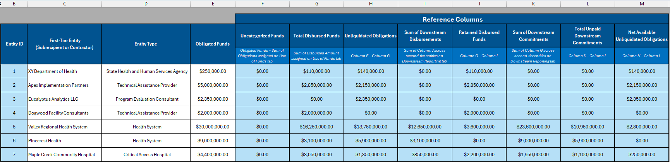

Additional Data Entry Considerations
The following information may be helpful to States in completing the First-Tier Entities tab:
- If a State intends to provide a first-tier entity with RHT Program funds that will be drawn from two or more budget periods, the State should enter the entity in the First-Tier Entities tab of each budget period’s workbook and track the Obligated Funds related to each budget period separately.
- If a first-tier entity enters into multiple agreements with the State related to funds from the same budget period award, the entity still only needs to be entered once on this tab. The value in the Obligated Funds column should be the total value of all such agreements. States will have the opportunity to separate this obligation into different initiatives, activities, and use of funds categories on the Use of Funds tab. A State should enter a first-tier entity on this tab once an obligation has been established with that entity, even if no funds have yet been disbursed to the entity.
- Any type of entity may be a first-tier entity, including specific agencies within the State Health and Human Services Department, other government agencies, specific healthcare providers or health systems, contractor organizations, etc.
- The State awardee agency should be entered as a first-tier entity in two cases: (A) if RHTP funds are kept within the agency to pay for administrative costs, such as staff salaries or (B) if the State awardee agency distributes funds directly to beneficiaries (since beneficiaries should not be reported, the State awardee agency is the last reportable recipient of obligated or disbursed funds).
- First-tier entities should be entered in consecutive rows, and rows should not be re-ordered or deleted. Entity IDs are dynamically assigned, so moving or deleting an entity from this list could create issues for the data on other linked tabs.
- The Entity Type field should be populated with the specific entity type that best describes the first-tier entity, such as “Critical Access Hospital,” “Rural Pharmacy,” or “State Labor Department.” Do not select a category label such as “Healthcare Providers” or “State Government Agencies.” These labels are only provided to make it easier to identify the relevant Entity Type from the drop-down menu. This field may not be left blank. States should consult the Entity Type Guidance tab when listing a new entity to ensure that the correct entity type is selected.
- The First-Tier Entities tab supports up to 300 line-items; States should contact their PO for additional guidance if they exceed this number of first-tier entities.

Reference Columns
The remaining light blue (protected) columns on the First-Tier Entities tab provide summary information for each first-tier entity based on the data that is entered on other linked tabs. This information is automatically populated and for reference only; States may find this information helpful for completing the Downstream Reporting tab or validating the disaggregated information entered on the Use of Funds tab.
  - Uncategorized Funds: This is a reporting field rather than an accounting field. Users should categorize all funds that have been obligated to a first-tier entity across initiatives and use of funds categories on the Use of Funds tab. This value is the Obligated Funds assigned to the first-tier entity minus the sum of the Obligation Amount column on the Use of Funds tab for all rows associated with the first-tier entity. This value should be 0 for all rows at the time of submission. A positive value indicates that not all obligated funds have been categorized, a negative value means that the user has categorized more funds than have been obligated, and a value of zero means that all obligated funds have been categorized in the Use of Funds tab.
  - Total Disbursed Funds: The sum of the Disbursed Amount column on the Use of Funds tab across all line items assigned to the first-tier entity.
  - Unliquidated Obligations: Obligated Funds minus Total Disbursed Funds.
The final five summary columns are based on information from the Downstream Reporting tab. These columns exist to help the State see the results of their Downstream Reporting entries in one place.
  - Sum of Downstream Disbursements: This column automatically adds together all the disbursed funds that the first-tier entity has passed down the chain to lower-tier subrecipients and contractors.
  - Retained Disbursed Funds: This column subtracts the Sum of Downstream Disbursements from the Total Disbursed Funds paid to the first-tier entity. This is the exact amount of cash the first-tier entity has received from the State that has not been passed on to another entity. This may be a disbursement that has not yet been transferred or paid to a subrecipient or contractor, or it may be funding that the first-tier entity has kept to fund its own direct, local operations.
  - Sum of Downstream Commitments: This column calculates the total commitments the first-tier entity has promised to subrecipients and contractors (second-tier entities).
  - Total Unpaid Downstream Commitments: This column subtracts the Sum of Downstream Disbursements from the Sum of Downstream Commitments. This is the total value of all commitments that have been made from the first-tier entity to its second-tier entities that have not been disbursed.
  - Net Available Unliquidated Obligations: This column subtracts the Total Unpaid Downstream Commitments from the Unliquidated Obligations of the first-tier entity. This is the amount of funds that have been obligated to the first-tier entity that have not yet been disbursed or committed to a downstream entity.

Use of Funds Tab

Overview
The Use of Funds tab captures how RHT Program funds are spent by tracking disbursed funds against obligations to first-tier entities. This includes identifying the initiative and use of funds category associated with each disbursement, as well as any applicable program-specific funding limitations.
The first step on the Use of Funds tab is to map an Obligation Amount to an entity that has been defined on the First-Tier Entities tab. If the Obligated Funds for an entity from the First-Tier Entities tab covers multiple initiatives or multiple use of funds categories, the Obligated Funds must be split into multiple line items (rows) in the Use of Funds tab so that disbursements can be properly attributed to the correct initiative and use of funds category. Obligated Funds reported on the First-Tier Entities tab must be allocated to Obligation Amount(s) on the Use of Funds tab based on three variables: First-Tier Entity (selected from a dropdown populated from column C of the First-Tier Entities tab), Initiative Number, and Use of Funds Category as defined in the Notice of Funding Opportunity (NOFO). Obligations spanning multiple initiatives or use of funds categories must be split into separate rows.
And lastly, for each row, States must capture the corresponding Disbursed Amount by initiative and use of funds category to accurately reflect how funds are being spent. States must also provide a description of the activities supported by the funds and identify the portion of the Disbursed Amount attributable to any applicable program-specific funding limitations defined in the NOFO.
Note that the Obligation ID column is not editable and is pre-populated. The Obligation IDs are the State’s two-letter abbreviation followed by a whole number; each Obligation ID is unique to a line item. The Obligation ID is not used elsewhere in the Excel Reporting Template. The Use of Funds tab supports up to 2,500 line items. States should contact their PO for additional guidance if they are at risk of exceeding this number of line items.

Data Entry: Defining Line Items
Mapping Obligation Amount to the First-Tier Entity: Every row on this tab must have an Obligation Amount assigned to an entity that has already been recorded on the First-Tier Entities tab. Because first-tier entities may manage complex, multi-faceted projects, the user may need to split the obligation into multiple rows to cover all required combinations of Initiative Number and Use of Funds Category column values.
Splitting Obligations: If an obligation to a first-tier entity covers multiple initiatives or multiple use of funds categories, it must be split into multiple line items so that disbursements can be properly attributed to the correct initiative and use of funds category. For example, if a health system receives a $30 million prime award, but $14 million is dedicated to Capital Expenditures & Infrastructure (Initiative 1) and $16 million is for piloting rural programs related to Appropriate Care Availability and Prevention and Chronic Disease (Initiative 2), the State must create at least three separate rows to accurately categorize these distinct funding pools (Figure 2).
Figure 2: Splitting an Obligation Across Initiatives and Use of Funds Categories
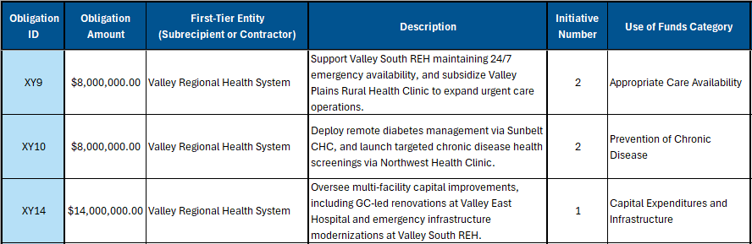
Aggregating Obligations: If multiple downstream projects are awarded to the same first-tier entity and fall under the same initiative and use of funds category, those funds can be entered as a single line item and disbursements made for any of those projects would be tracked in that row. For example, if a health system uses funds to conduct multiple different renovation projects at different hospitals under the "Capital Expenditures and Infrastructure" category, this can be combined into one row (Figure 3).
Figure 3: Aggregating an Obligation with Multiple Downstream Projects
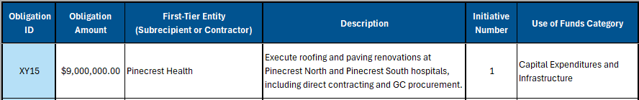
Enter Programmatic Details and Disbursement Information: For each line item, in addition to the Initiative Number and the Use of Funds Category, the user must enter a description and the amount of funds that have been disbursed so far. The description should be a brief, high-level summary of the activities being funded by this specific amount (e.g., "Subsidize urgent care operating hours and execute remote diabetes management program").
If an obligation to a first-tier entity has been split into multiple line items that cover multiple initiatives or use of funds categories, States should map the disbursed funds to the appropriate line items to enable CMS to track disbursements by initiative and use of funds category. If no disbursement has been made for a given row, the State should enter 0 in the Disbursed Amount column. The Description, Initiative Number, Use of Funds Category, and Disbursed Amount columns are required and may not be left blank.
In addition to the use of funds categories listed in the NOFO, the workbook contains an “Administrative Costs” option within the Use of Funds Category dropdown. This option may be selected if the State determines no use of funds categories apply to the obligation because it is a purely administrative expense. If this use of funds category is selected for the line item, then the Obligation Amount should also be entered in the Administrative Costs program-specific limitation field (see the Program-Specific Limitations section of this document for more details).
Additionally, there is an “All” option within the Initiative Number dropdown. This “All” initiatives option may be selected if an obligation (or part of a split obligation) could reasonably be attributed evenly to all of the State’s initiatives. For example, if a State awardee agency uses RHT program funds on administrative staff within the agency or hires a contractor that will support oversight of all of their initiatives, those obligations may be attributed to “All” initiatives in one line (Figure 4). This example also demonstrates that States are required to report disbursements that remain within the awardee agency for administrative costs such as staff salaries on the Use of Funds tab. Note that this requires the State awardee agency to be added as a first-tier entity on the First-Tier Entities tab.
Figure 4: "All" Initiative Selection
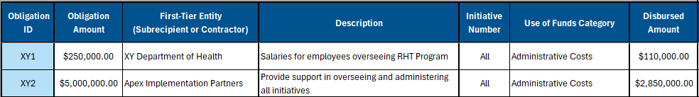

Data Entry: Program-Specific Limitations
Program-specific limitations are outlined in the NOFO. The limitations are summarized below in Figure 5.
Figure 5: Program-Specific Limitations and Amount of Award
Program-Specific Limitation | Amount of Award
Administrative Costs | 10%
Provider Payments (Category B) | 15%
Capital Expenditures and Infrastructure (Category J) | 20%
EMR Replacement | 5%
Rural Tech Catalyst Fund | 10% or $20 million, whichever is less

Each program-specific limitation has a corresponding column in the Use of Funds tab. For each line item, enter the amount of disbursed funds that should be counted towards each program specific limitation (blanks are treated as zero). It is possible that no program specific limitations apply to a line item. If no limitations apply, the State should indicate this in column N of the Use of Funds tab by selecting “No limitation applicable.”. The State may fill out multiple program-specific limitation fields for a single line item, but funds should not be double-counted across multiple program-specific limitations; each dollar may be assigned to at most one program-specific limitation. The funds assigned to program-specific limitation categories should therefore sum to no greater than the line-item’s Disbursed Amount.

Two of the program-specific limitations overlap with use of funds categories: Provider Payments and Capital Expenditures and Infrastructure. The full Disbursed Amount of a line item must be assigned to either the respective program-specific limitation field or the Administrative Costs program-specific limitation field if one of those two categories is selected.

Similarly, if “Administrative Costs” is selected as the use of funds category, then the full Disbursed Amount must be populated in the Administrative Costs program-specific limitation field.

Downstream Reporting Tab

Overview
The goal of the Downstream Reporting tab is to provide CMS with greater visibility into how RHT Program funds are distributed across entity types over time. Each line item on this tab represents a single, direct subaward or contract between a parent entity and a downstream entity. These line items are used to track both the funds that are committed (if any) from the parent entity to the downstream entity as well as the funds that are actually transferred or paid. Additional rows of data and updates to relevant financial values should be made on the Downstream Reporting tab as new information is available to the State through their monitoring of downstream entities.

Reporting Instructions
States should complete only the unprotected white cells on this tab. Light blue cells are protected and automatically populated using formulas and should not be edited. Figure 6 displays example data from the State XY scenario.
Figure 6: Downstream Reporting Table
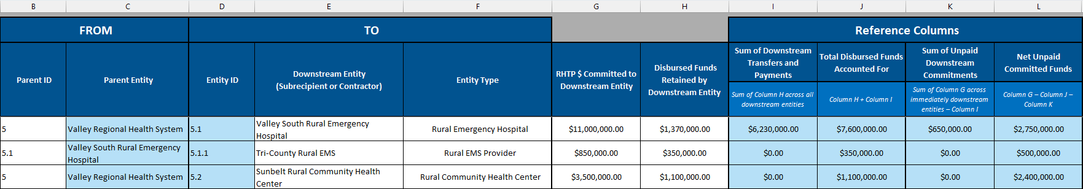
Each row represents a direct financial relationship between two entities. Columns B and C identify the Parent ID and Parent Entity making the commitment or payment, while columns D through F identify the downstream entity receiving the funds, including its Entity ID, name, and entity type. The remaining light blue reference columns are used to track the financial status of each downstream relationship.
Parent ID (Column B): The user must enter the Entity ID associated with the entity providing the funds. For a relationship between a first-tier entity and a second-tier entity, enter the first-tier entity’s Entity ID from column C of the First-Tier Entities tab. However, for relationships with second to third-tier entities, or any subsequent tiers, the Parent ID will instead be determined by the Entity ID in column D of the Downstream Reporting tab.
As seen in Figure 6, the State enters “5” as the Parent ID for a commitment from Valley Regional Health System to Valley South Rural Emergency Hospital, which the workbook defines as Entity ID 5.1 in column D. Then in the next row, 5.1 is used as the Parent ID to track a commitment from Valley South Rural Emergency Hospital to Tri-County Rural EMS.
Parent Entity (Column C): This column displays the entity name associated with the Parent ID.
Entity ID (Column D): This column assigns an Entity ID to the downstream entity. This Entity ID can then be input as the Parent ID in any subsequent row of the Downstream Reporting tab.
Downstream Entity (Column E): The user should enter the legal name of the organization that is the recipient of the commitment, subaward, or contract described by the line item.
Entity Type (Column F): The user should select the most appropriate Entity Type from the dropdown, using the definitions on the Entity Type Guidance Tab for additional guidance.
RHTP $ Committed to Downstream Entity (Column G): The user must enter the dollars that the parent entity has committed to the downstream entity. Committed funds do not require (but may have) a fully executed contract or legally binding agreement to be recorded, so the value in this column may reflect the deliberate earmarking of a budget for a specific downstream entity or purpose, even without a legally binding contract. Note that all downstream disbursements are definitionally preceded by the commitment of those funds to the downstream entity, which is why this value must be greater than or equal to the Total Disbursed Funds Accounted For and Net Unpaid Committed Funds must be non-negative. Note that the definition of committed funds (used for all second-tier and later entities) is broader than the definition of obligated funds, which is used only for the State awardee's direct relationships with its first-tier entities.
Disbursed Funds Retained by Downstream Entity (Column H): In this column, the user must enter the portion of the total disbursed funds that the downstream entity has not transferred or paid further downstream. These may be funds that either (1) are intended to be transferred or paid downstream but were held by the entity at the time of reporting, or (2) are used by the entity to implement initiative activities, such as internal administration, payroll for its own staff, or the purchase of materials.
This amount represents the disbursed RHT Program cash that has stopped at this entity and has not been passed further down the chain. Note that if a reporting period ends between the time that an entity received disbursed RHT Program funds and the time it is transferred or paid to a downstream entity, those funds would be tracked in this field even if some or all of the funds will be sent further downstream.
Sum of Downstream Disbursements (Column I): This column sums all the cash that has passed from this entity to its downstream entities. It shows how much of the cash it received was subsequently transferred or paid out.
Total Disbursed Funds Accounted For (Column J): This column is sum of the Disbursed Funds Retained by Downstream Entity and the Sum of Downstream Disbursements. This represents the total cash that has ever been transferred or paid to this entity, regardless of what share of that cash has been retained.
Sum of Unpaid Downstream Commitments (Column K): This column is the sum of the entity’s commitments to its immediately downstream entities minus the Sum of Downstream Disbursements.
Net Unpaid Committed Funds (Column L): This column calculates the remaining undisbursed balance of the funds committed to this entity. This is the RHTP $ Committed to Downstream Entity minus Total Disbursed Funds Accounted For minus Sum of Unpaid Downstream Commitments. This value shows how much money is still available to be disbursed to downstream entities or retained for local operations.

Additional Data Entry Considerations
- The generated Entity ID is tied to the relationship with the Parent Entity ID (and consequently the first-tier entity that received funding from the State), not the downstream entity’s name. This means that if the same entity receives committed or disbursed funds from two different Parent Entity IDs, it would be assigned two different Entity IDs that are not tied to each other in any way. See the example of Solomon Brothers Commercial Roofing in Figure 7. Solomon Brothers is assigned Entity ID 6.1.1.1 from the payment it receives from Summit General Contractors and Entity ID 6.2.1 from the payment it receives from Pinecrest South Hospital.
Figure 7: Multiple Entity IDs to Same Entity
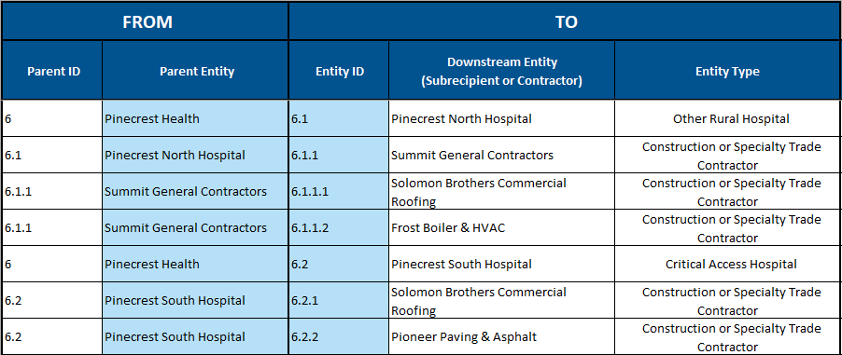
- Committed and disbursed funds from the same Parent Entity ID to the same downstream entity should be aggregated into one row even if the committed or disbursed funds span multiple initiatives or use of funds categories. In Figure 8, Valley Regional Health System (Entity ID #5) is a first-tier entity for both initiatives 1 and 2. For both initiatives, it subawards some of its obligated funds to Valley South Rural Emergency Hospital (5.1). Valley South Rural Emergency Hospital transfers funds to Tri-County Rural EMS (5.1.1) to implement initiative 2 and pays Horizon Construction Group (5.1.2) and Valley South Electrical (5.1.3) to implement initiative 1. Nowhere on this tab is the user required to indicate which funds are associated with each initiative.
Figure 8: Aggregation on Downstream Reporting Tab
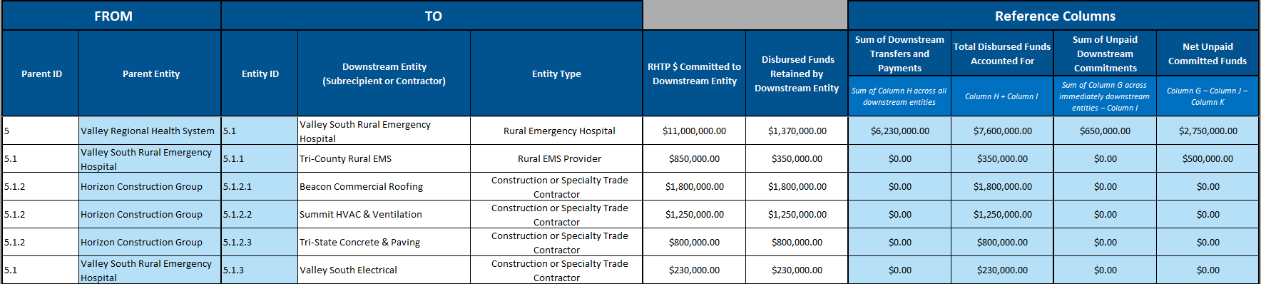

Appendix A: State XY Example Scenario
To illustrate the reporting process across the First-Tier Entities, Use of Funds, and Downstream Reporting tabs, this guide uses a simplified model of State XY’s RHT Program consisting of four initiatives.
The examples demonstrate how RHT Program funds are reported from the State awardee to first-tier entities and, when applicable, through additional downstream entities. All screenshots of the Obligated and Spent Funds Reporting tabs used in this guide are populated with this simplified example data. Please note that numbers in this example data were selected for illustrative purposes in demonstrating the workbook’s function and do not necessarily reflect realistic values for each activity.

State XY First-Tier Entities
Below are the first-tier entities with which the State XY Department of Health (the awardee agency) has entered into legally binding funding agreements:
- To administer the overall program, the State has direct agreements with two first-tier entities: Apex Implementation Partners, which provides general technical assistance and implementation support, and Eucalyptus Analytics LLC, which provides program evaluation services for Initiatives 2 and 3.
- The State, XY Department of Health, is also entered as a first-tier entity to account for RHT Program funds retained within the agency for personnel and other allowable program administration costs.
- Beyond these overarching activities, the State has direct agreements with additional first-tier entities responsible for implementing individual initiatives.
Each entity receiving RHT Program funds directly from the State awardee should be included on the First-Tier Entities tab. An entity only needs to be established once on that tab, even if it participates in multiple initiatives. The associated obligations and expenditures are reported on the Use of Funds tab, while applicable funding commitments, payments, and transfers beyond the first-tier are reported on the Downstream Reporting tab.

State XY Initiatives
Initiative 1: Infrastructure Revitalization
This initiative funds minor renovations and minor alterations and equipment updates to existing healthcare facilities. Eligible projects include repurposing existing buildings to offer new clinical services, installing soundproofing to offer telehealth services, and repairing equipment at rural hospitals. To execute this, the State has contracted directly with Dogwood Facility Consultants to evaluate facility needs, direct the flow of funds, and oversee vendor bidding. The State has also distributed direct prime funding to two major regional networks (Valley Regional Health System and Pinecrest Health) and four independent rural healthcare providers (Maple Creek Community Hospital, Ridgeview Memorial Hospital, Oak Valley Health Center, and Lakefront Area Medical Center) to manage physical upgrades within their respective facilities.
Initiative 2: Rural Health Service Pilots & Care Availability
Focused on generating data to inform long-term healthcare investments, this initiative provides direct funding to pilot new rural health services. The pilots are each built on one of the RHT Program use of funds categories of prevention and chronic disease, provider payments, and appropriate care availability. The State has engaged three first-tier entities to execute these pilots, often involving transferring funds downstream to owned clinics or other healthcare facilities to engage in pilot activities. These first-tier entities are Valley Regional Health System, Maple Creek Community Hospital, and Ridgeview Memorial Hospital. Note that all three of these first-tier entities are already included in Initiative 1, so they would not need to be entered separately on the First-Tier Entities tab.
Initiative 3: Workforce Training and Education
This is a highly collaborative, multi-agency initiative designed to expand the rural healthcare workforce pipeline. Because the State relies on existing statutory infrastructure, this initiative is executed entirely through direct first-tier inter-agency agreements. The XY Department of Labor and Workforce Development (DOL) subawards funds down to the State Workforce Board and various regional/tribal entities. Simultaneously, the XY Department of Education (DOE) provides funding to Rural GME sponsors, medical universities, and rural clinical training programs to support approved workforce development activities.
Initiative 4: Technology Upgrades
This initiative focuses on digital modernization, interoperability, and telehealth expansion. Because these activities require proprietary software licenses and direct professional services, the State acts as the direct procuring entity, contracting with four major commercial IT vendors. These first-tier entities include Chartwell EMR Solutions for system migrations; Verdant Springs Telehealth for remote clinic outfitting; Vanguard Cybersecurity for cybersecurity implementation and staff training; and Streamline Grants Inc., the vendor responsible for running the procurement process for the initiative.

Appendix B: Conditional Formatting Rules
All of the data entry tabs in the Obligated and Spent Funds Reporting section have conditional formatting rules to assist with data entry. Cells will highlight yellow (for incompleteness) or red (for data entry errors) based on a variety of rules pertaining to either missing or incorrect values. The conditional formatting rules for each tab are described below.
First-Tier Entities Tab
- The Entity Type dropdown may not be used to select a category label. The State should only use the indented entity types in the dropdown list; the category labels are only an organizational tool.
- None of the dollar values in columns E–M may be negative. This includes both input and calculated values. If any calculated values are negative, it means that there is an error or a value that needs to be updated on at least one tab.
- The values in column F should be equal to zero at the time of submission.
Use of Funds Tab
- The sum of Obligation Amounts assigned to a given first-tier entity may not exceed the Obligated Funds assigned to that entity on the First-Tier Entities tab.
- If the Obligation Amount and First-Tier Entity columns are not blank, the Description, Initiative Number, Use of Funds Category, and Disbursed Amount columns must be populated as well.
- The Disbursed Amount for a line item may not exceed its Obligation Amount.
- If an amount is entered into the Capital Expenditures and Infrastructure or Provider Payments Program-Specific Limitations fields, the Use of Funds Category value should align.
- If a non-zero amount is entered into the Disbursed Amount column, the program-specific limitation information must be filled out. If no program-specific limitations apply, the confirmation field must be populated with “No limitation applicable.”.
- If a non-zero amount is entered into any of the program-specific limitation fields, the confirmation field should be left blank.
- The amounts attributed to program-specific limitations cannot sum to greater than the Disbursed Amount in the line item.
- If the “Administrative Costs” use of funds category is selected for the line item, then the program-specific limitation Administrative Costs column must be equal to the Disbursed Amount.
- If the Provider Payments use of funds category is selected for the line item, then the program-specific limitations Administrative Costs and Provider Payments columns must sum to the Disbursed Amount.
- If the Capital Expenditures and Infrastructure use of funds category is selected for the line item, then the program-specific limitations Administrative Costs and Capital Expenditures and Infrastructure columns must sum to the Disbursed Amount.
Downstream Reporting Tab
- The Parent ID must be an Entity ID defined on either the First-Tier Entities tab or in an earlier row on the Downstream Reporting tab.
- The Entity Type dropdown may not be used to select a category label. The State should only use the indented entity types in the dropdown list; the category labels are only an organizational tool.
- None of the dollar values in columns G–L may be negative. This includes both input and calculated values. If any calculated values are negative, it means that there is an error or a value that needs to be updated on at least one tab.

Appendix C: Table of Figures
Figure 1: First-Tier Entities Table 6
Figure 2: Splitting an Obligation Across Initiatives and Use of Funds Categories 10
Figure 3: Aggregating an Obligation with Multiple Downstream Projects 10
Figure 4: "All" Initiative Selection 11
Figure 5: Program-Specific Limitations and Amount of Award 11
Figure 6: Downstream Reporting Table 12
Figure 7: Multiple Entity IDs to Same Entity 15
Figure 8: Aggregation on Downstream Reporting Tab 15

The Downstream Reporting tab is not required for the first Annual Report. Please see the Notes for the First Annual Report section below for further details.

