- Task Screen with Login.gov Proofing selected
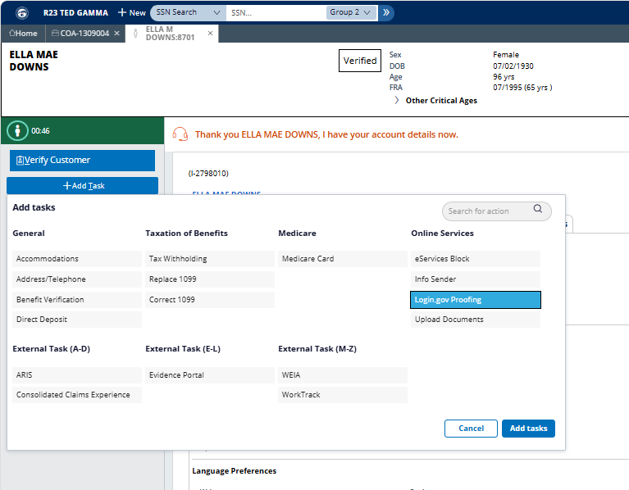

- IPP Account Check – Consent
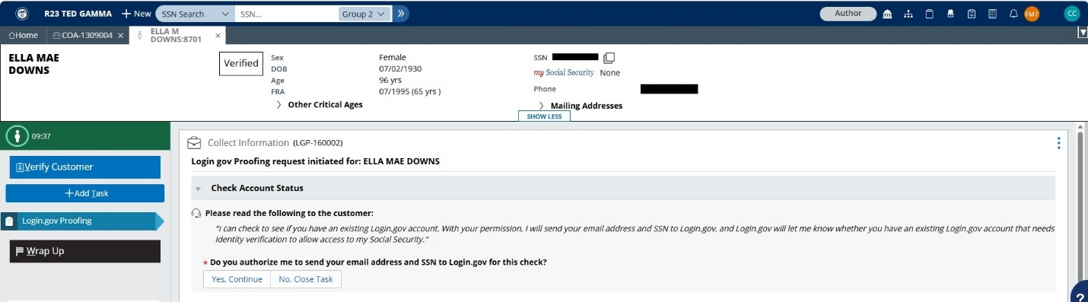

- IPP Account Check – Consent selected and required email entered to complete Account Check process
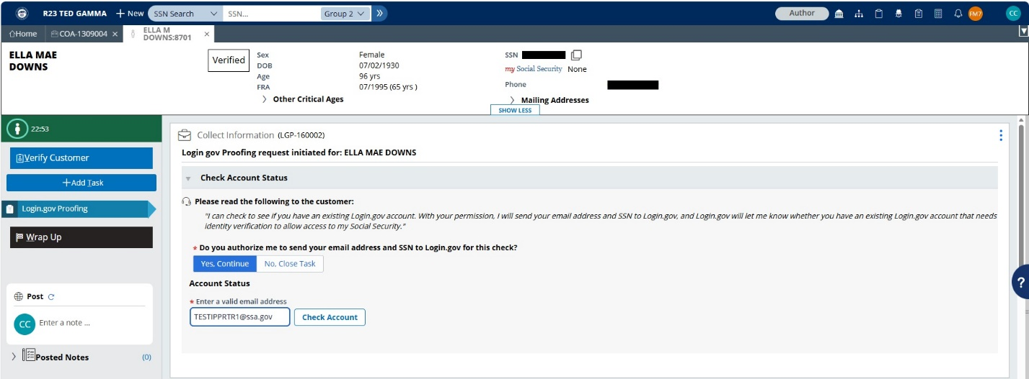

- IPP Account Check – “Check Account” button selected
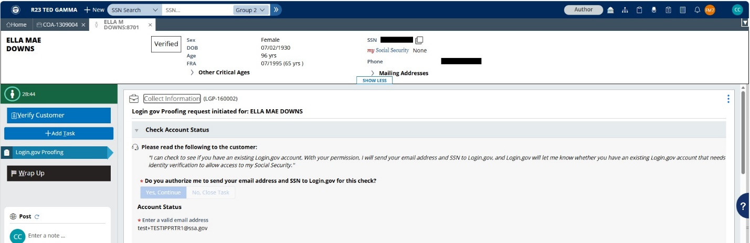

- IPP – Account check complete and verification process to elevate from IAL1 to IAL2 initiated with consent.
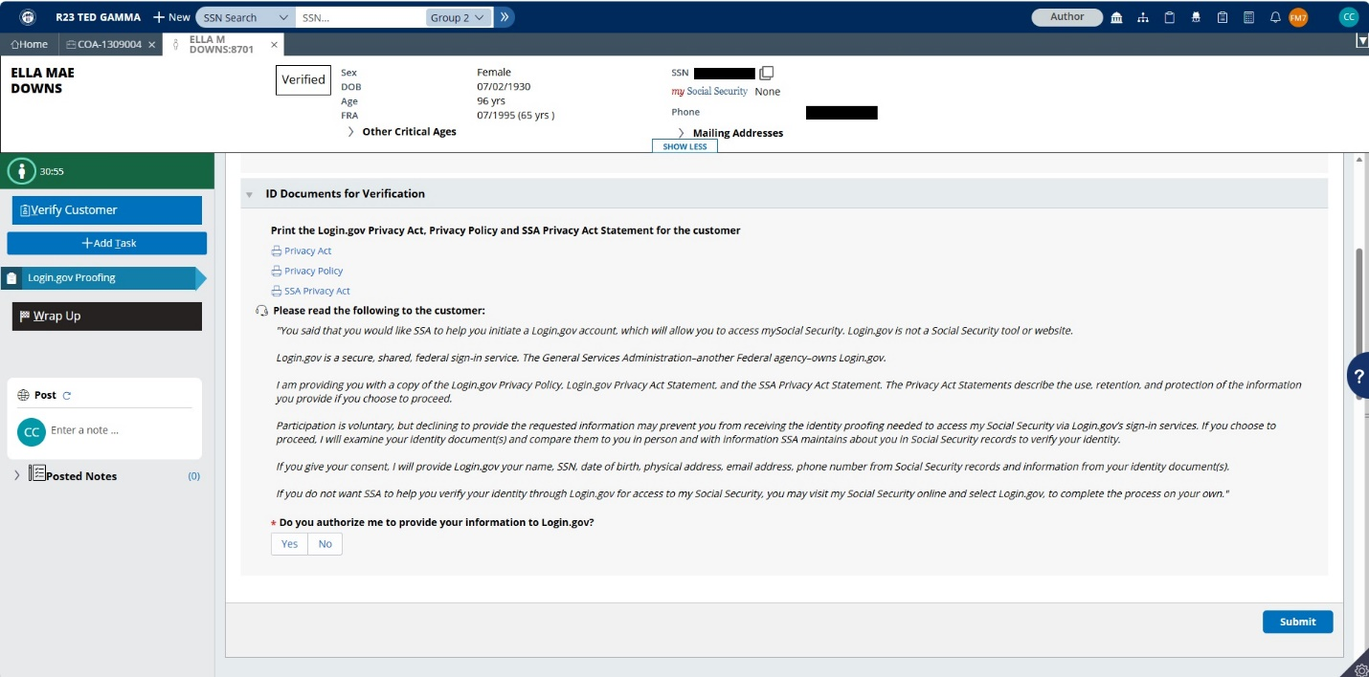

- IPP – Account check complete and verification process to elevate from IAL1 to IAL2 initiated with consent “Yes”
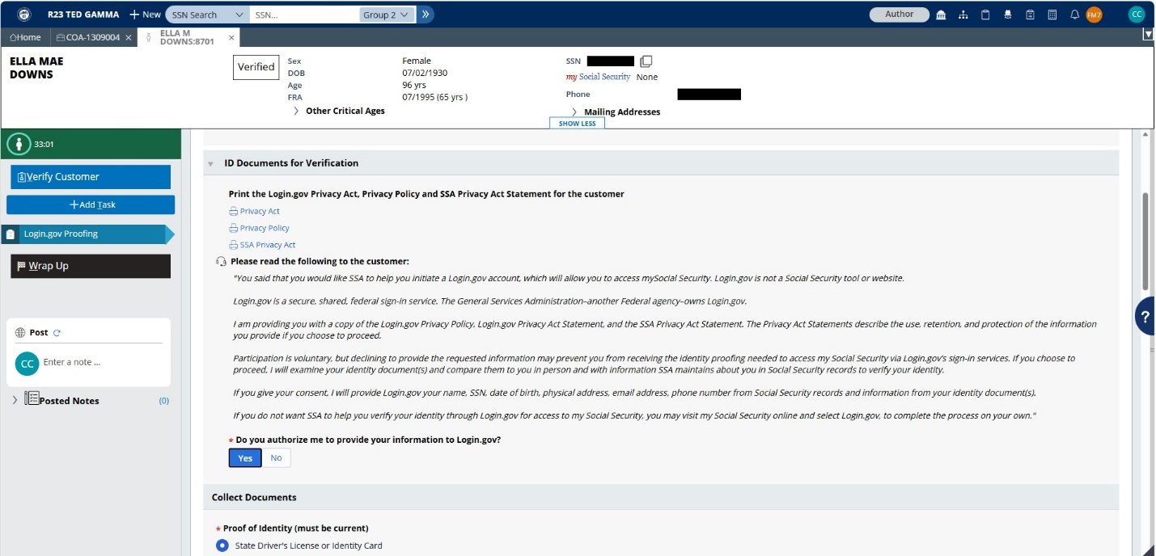

- IPP Customer Verification - Process to elevate from IAL1 to IAL2 with required ID proofing information
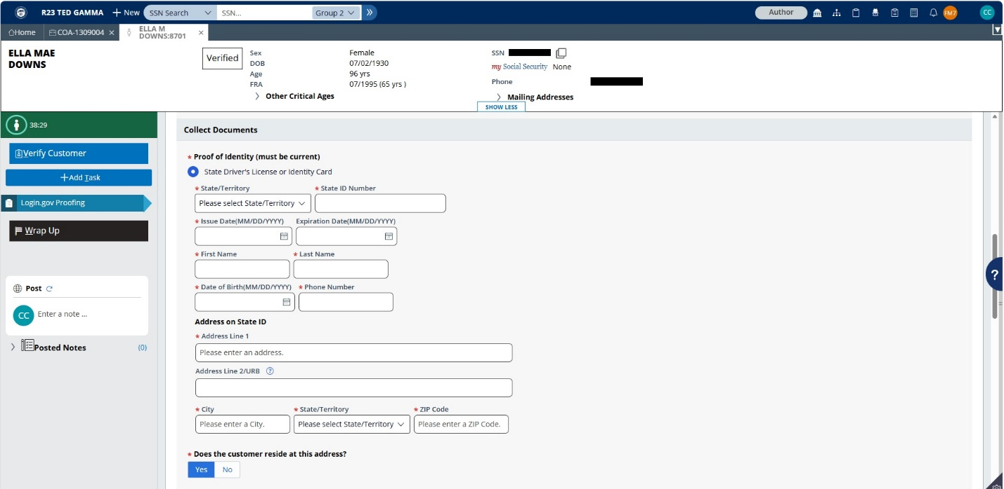

- IPP Customer Verification - Process to elevate from IAL1 to IAL2 with required ID proofing information (cont’d)
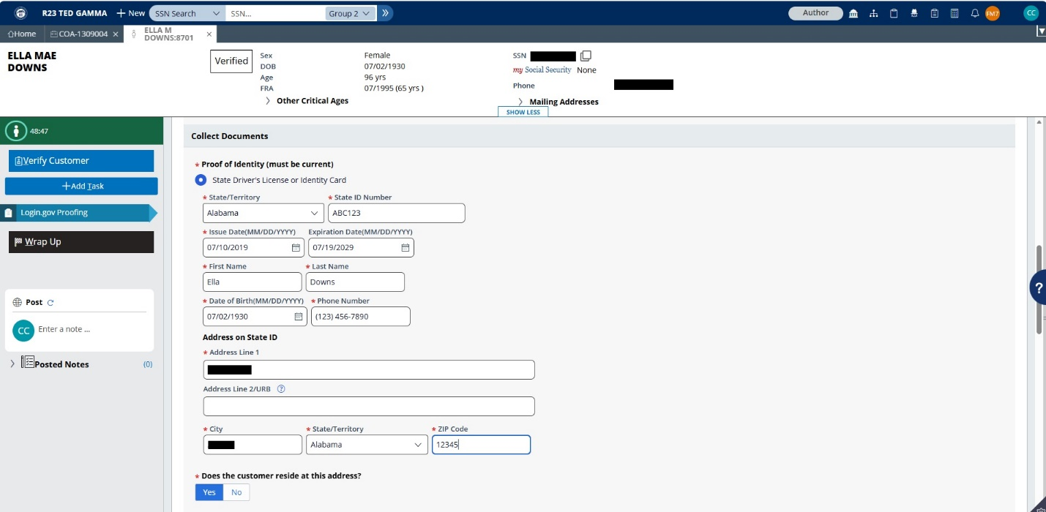

- IPP Customer Verification - Additional fields if Residence address is different from address on State ID.
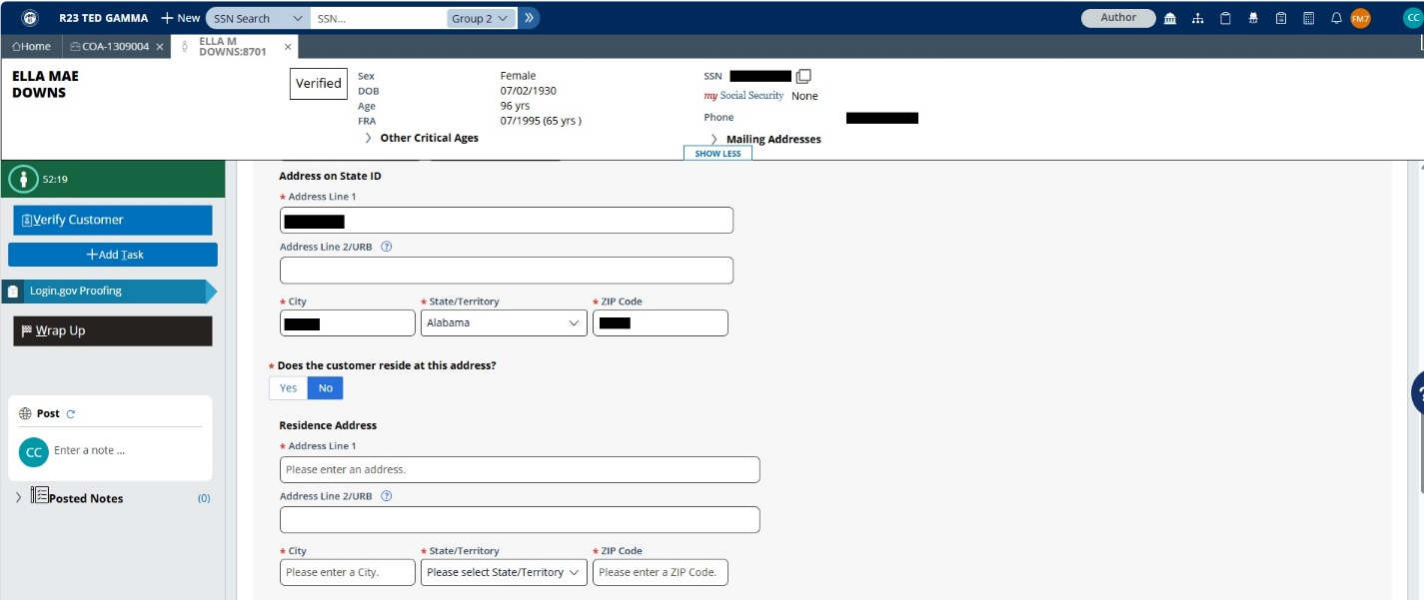

- IPP Customer Verification – Required ID proofing information submitted to elevate from IAL1 to IAL2
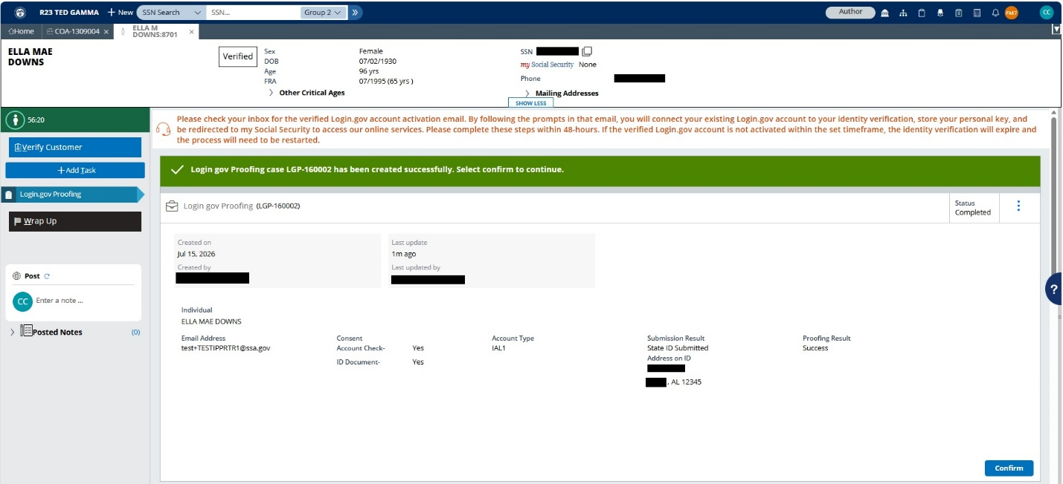

- IPP Customer Verification – Required ID proofing information submitted to elevate from IAL1 to IAL2 (cont’d) – selected “Confirm”
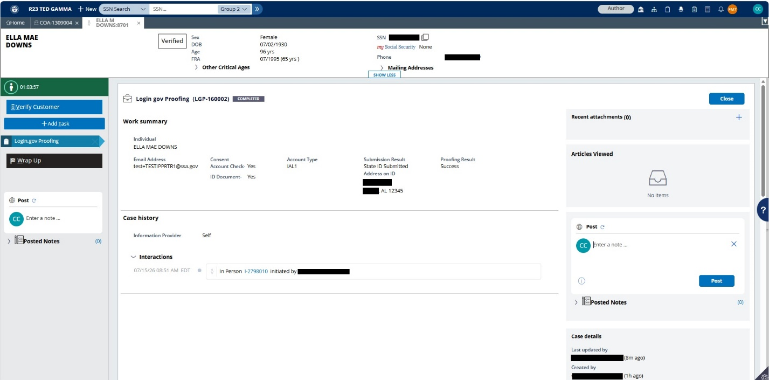
- IPP Customer Verification – Required ID proofing information submitted to elevate from IAL1 to IAL2 (cont’d)
