Justification for No-Material or Nonsubstantive Change to Currently Approved Collection

AGENCY: Pension Benefit Guaranty Corporation (PBGC)

TITLE: Payment of Premiums (29 CFR part 4007)

STATUS: OMB control number 1212-0009; expires September 30, 2028

CONTACT: Jose Singer-Freeman (202-229-5432)

PBGC is making non-material changes to the approved information collection for the computation and payment of premiums to PBGC under title IV of the Employee Retirement Income Security Act of 1974 (ERISA) for plan years beginning in 2027.

The changes to the filing instructions are as follows:

- Updated the “What’s New” section to highlight the 2027 premium rates and cap, the new question related to premium overpayment refunds, and clarification regarding 401(h) accounts.

- Replaced references to the 2026 statutory premium rates and cap with the statutory premium rates and cap applicable for 2027 (throughout the instructions).

- Updated dates and due dates to reflect 2027 plan year (throughout the instructions).

- Clarified that individuals with benefits solely under a plan’s 401(h) component (which pays for retiree medical benefits) are not counted as participants for premium purposes and made minor additional clarifications.

The changes to the MyPAA electronic portal are as follows:

- Added a question on the “Premium Overpayment Options” page asking whether the account designated for an ACH refund is a trust account and made corresponding changes to the instructions.

The changes made to the filing instructions and to the MyPAA electronic portal will not increase the hour or cost burden for this information collection.

We specifically note these language revisions:

- On page 11, the instructions were revised to clarify that individuals with benefits solely under a plan’s 401(h) component are not participants for premium purposes:
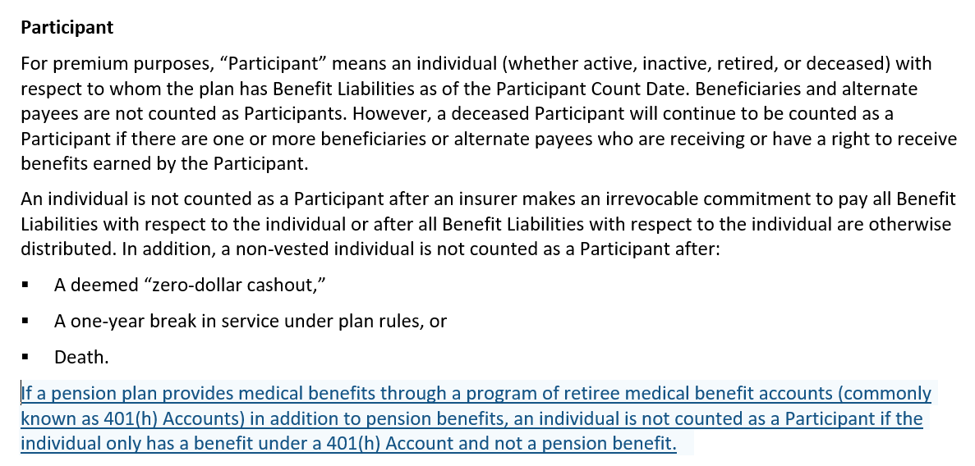

- On page 44, the instructions were revised to reflect a new question on whether the bank account receiving a refund is a trust account:

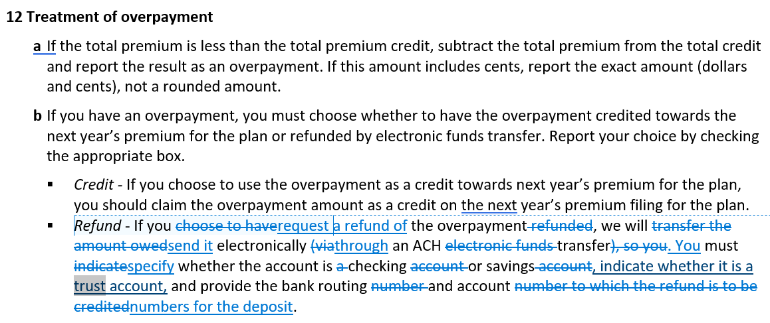

- The MyPAA electronic portal was revised to add a question on whether the bank account is a trust account:

