TSA Gateside by TSA PreCheck Request Mockup:
OMB 1652-0046
Exp. 1/31/2029

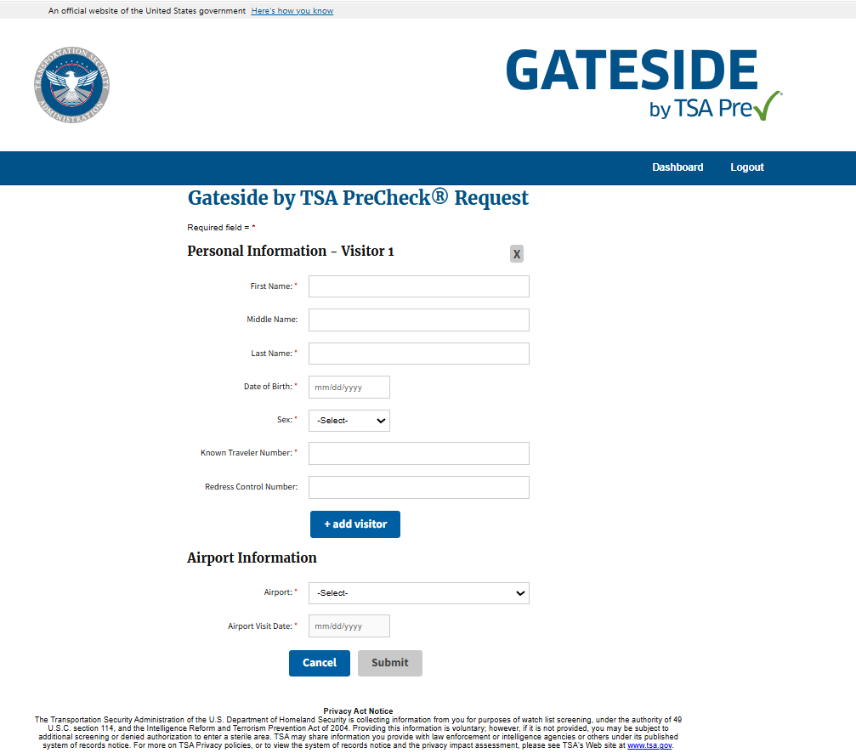

TSA Visitor Pass Dashboard Mockup: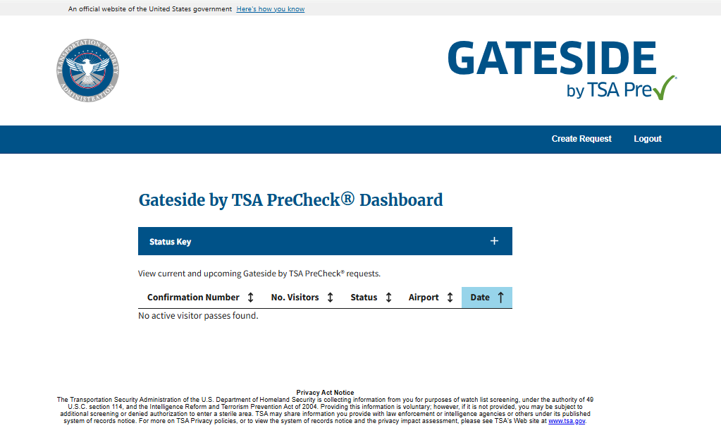

(Opening the Actions tab will display the information entered on the portal when requesting the gate pass as well as the result for everyone on the request. No additional information will be on this page.)

Paperwork Reduction Act Statement: TSA is collecting this information to allow non-traveling individuals to request authorization to enter a sterile area at a U.S. airport. The public burden for this voluntary collection of information is estimated to be approximately 2 minutes. An agency may not conduct or sponsor, and persons are not required to respond to a collection of information, unless it displays a valid OMB control number. The OMB control number assigned to this collection is 1652-0046, which expires 01/31/2029. Send comments regarding this burden estimate or collection to: TSA-11, Attention: PRA 1652-0058, Secure Flight Program, 6595 Springfield Center Drive, Springfield, VA 20598-6011.

