Participant Screen: 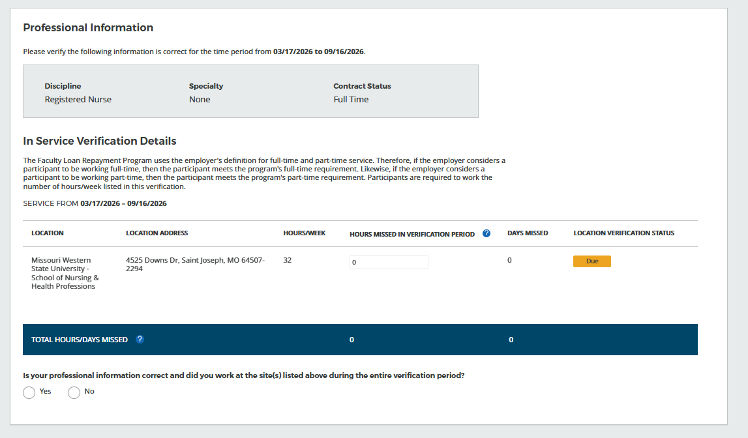

Point of Contact (POC) Screen:
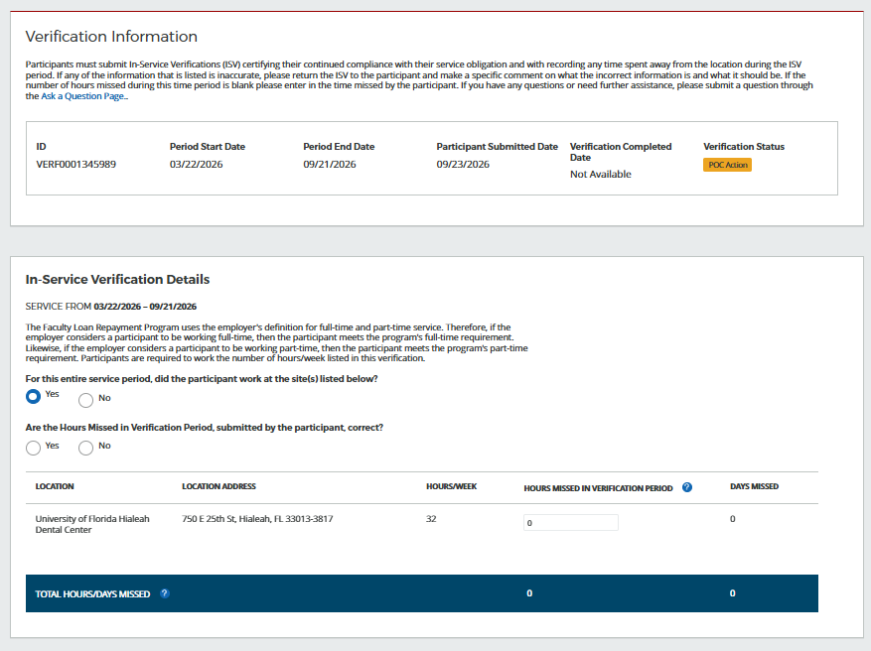

Public Burden Statement:
The purpose of this information collection is to obtain information through the Faculty Loan Repayment Program (FLRP), which is used to assess an applicant’s eligibility and qualifications for the FLRP. An agency may not conduct or sponsor, and a person is not required to respond to, a collection of information unless it displays a currently valid OMB control number. The OMB control number for this information collection is 0906-0082 and it is valid until xx/xx/xxxx. This information collection is required to obtain or retain a benefit (Section 738(a) of the Public Health Service Act (42 USC 293b (a)). The information is protected by the Privacy Act, but it may be disclosed outside the U.S. Department of Health and Human Services, as permitted by the Privacy Act and Freedom of Information Act, to Congress, the National Archives, and the Government Accountability Office, and pursuant to court order and various routine uses as described in the System of Record Notice 09-15-0037. Public reporting burden or this collection of information is estimated to average xx hours per response, including the time for reviewing instructions, searching existing data sources, and completing and reviewing the collection of information. Send comments regarding this burden estimate or any other aspect of this collection of information, including suggestions for reducing this burden, to HRSA Information Collection Clearance Officer, 5600 Fishers Lane, Room 14N39, Rockville, Maryland, 20857.

